Egyptian E-Learning University

Faculty of Computers & Information Technology

GreenMind
By
Name Salma Samy Zakariya | ID 2201958
Name Shrouk yasser mohamed | ID 2201969
Name Rehab Mohamed Mohamed | ID 2201999
Name Tasnim Qutb Abdelaty | ID 2202015
Name Rana Sofi Ibrahim | ID 2202003
Name Mayar Ragab Mahmoud | ID 2202004
Name Seif Mohamed hosny abd alaziz | ID 2202128
Name Mohamed Abdeltawab Rajab | ID 2200047

Supervised by
Dr. Samar Hesham
Assistant
Eng. Ziad Mohamed

[Cairo]-2026

Abstract
The Green Mind – AI-Powered Smart Farming System is an advanced graduation project designed to tackle major challenges faced by farmers in both traditional and modern agricultural practices. Agriculture remains a critical sector worldwide; however, many farmers still rely on experience-based decisions rather than data-driven solutions. This often results in incorrect crop selection, improper fertilizer usage, delayed disease detection, and reduced productivity.
Green Mind bridges the gap between agricultural expertise and farmers by leveraging artificial intelligence to provide accurate, real-time farming recommendations. The system offers an integrated digital platform that supports farmers throughout the entire crop lifecycle, from crop selection to disease management and agricultural consultation.
At its core, the AI-based Crop Recommendation Module analyzes soil nutrients (Nitrogen, Phosphorus, Potassium), pH levels, and environmental factors including temperature, humidity, month of planting, soil type, and region to recommend the most suitable crop for cultivation. This enables farmers to make informed decisions that align with their land conditions, improving both yield quality and sustainability.
The Fertilizer Recommendation Systemsuggests the appropriate type of fertilizer based on the detected nutrient deficiency, crop type, growth stage, and soil characteristics, along with a clear explanation of why this fertilizer was selected and the recommended application method This addresses the common problem of fertilizer misuse, which can damage crops, degrade soil quality, and increase production costs.
A key feature of the project is the Plant Disease Detection System, which utilizes image processing and deep learning techniques to identify plant diseases at early stages. Farmers can upload images of plant leaves, and the system analyzes them to detect potential diseases. Early detection allows for timely corrective actions, reducing crop loss and enhancing overall farm productivity.
Additionally, Green Mind integrates an AI-powered Agricultural Chatbot, serving as a virtual assistant to answer farmers’ queries regarding crop management, fertilizers, diseases, irrigation methods, and general agricultural practices. This continuous support reduces dependency on agricultural experts and ensures farmers have access to reliable guidance anytime.
By combining crop recommendation, fertilizer guidance, disease detection, and conversational AI into a unified platform, Green Mind provides a comprehensive solution to the challenges faced by farmers. The system promotes smart farming practices, enhances decision-making accuracy, and contributes to sustainable agriculture. This project highlights the transformative potential of artificial intelligence in agriculture, demonstrating how intelligent systems can empower farmers, increase efficiency, and support global food security.
Furthermore, the platform facilitates the practical implementation of these recommendations through an integrated marketplace, allowing farmers to directly acquire the necessary seeds, tools, and fertilizers.

Acknowledgments
We would like to express our deepest appreciation and gratitude to Dr. Samar for her valuable guidance, continuous support, and constructive feedback throughout the duration of this project. Her academic expertise, dedication, and passion for the field played a significant role in strengthening our understanding and enhancing the overall quality of this work.
We also extend our sincere thanks to Teaching Assistant Ziad Mohamed for his technical support, ongoing assistance, and practical guidance, which were essential to the successful completion of this project. His commitment and willingness to share his knowledge greatly contributed to overcoming many technical challenges.
Furthermore, we would like to acknowledge all team members for their cooperation, dedication, and hard work. Each member contributed unique skills and perspectives that collectively led to the achievement of the project’s objectives.
Finally, we would like to express our gratitude to everyone who supported us throughout our academic journey, including family, friends, and colleagues. Their encouragement, patience, and understanding were invaluable to our success.
We sincerely thank all those who played a role in making this project a reality, and we deeply appreciate every contribution made.
Sincerely, Green Mind Project Team

Contents
Abstract 2
Acknowledgments 3
1.1 Background 11
1.2 Problem Statement 12
1.3 Motivation 13
2.1 Introduction 20
2.2 Plant Disease Detection Using Deep Learning 20
2.2.1 Early CNN-Based Approaches (2021) 20
2.2.2 Lightweight Models for Mobile Deployment (2022) 20
2.2.3 Comparative Studies of Advanced Architectures (2024) 21
2.2.4 Explainable AI in Plant Disease Detection (2025) 21
2.3 Crop and Fertilizer Recommendation Systems 21
2.4 Agricultural Chatbots and Conversational AI 22
2.5 Gaps in Current Solutions 22
2.5.1 Lack of Integrated Agricultural Platforms 22
2.5.2 Absence of Immediate Expert Guidance 22
2.5.3 Limited Arabic Language Support 23
System Analysis and Requirements 24
3.1 Introduction 25
3.2 System Overview 25
3.3 Approach Used to Solve the Problem 25
3.3.1 Problem Identification 25
3.3.3 Implementation Methodology 26
3.3.4 Project Timeline 26
3.4 Stakeholders and User Roles 27
3.5 User Stories 27
3.5.1 AI & Agricultural Smart Features 27
3.5.2 E-Commerce & Agricultural Store Module 27
3.5.3 System Administration Module 28
3.6 System Requirements 28
System requirements define what the system must accomplish and the conditions under which it operates. 28
3.6.1 Domain Requirements 28
3.6.2 Functional Requirements 28
3.6.3 Non-Functional Requirements 29
3.7 System Design Overview 29
3.8 System Architecture 29
3.8.1 Use Case Diagram 29
3.9.1 Machine Learning Algorithms 31
3.9.2 Backend Framework 32
3.9.3 Frontend Framework 32
4.1 Introduction 34
4.2 Dataset Description 35
4.2.1 Plant Disease Detection Dataset 35
4.2.2 Fertilizer Recommendation Dataset 35
4.2.3 Crop Recommendation Dataset 35
4.2.4 Multilingual Farming FAQ Dataset 36
4.2.5 Synthetic Data Generation Methodology 36
4.2.6 Agricultural Knowledge PDF Dataset 36
4.3 Dataset Integration Strategy 37
4.4 Ethical and Data Considerations 37
5.1 Introduction 39
5.2 Technologies, Tools, and Programming Languages Used 39
5.2.1 Programming Languages 40
5.2.3 Backend Frameworks & Infrastructure Architecture 40
5.2.4 Frontend Frameworks & Web Design Tools 41
5.2.5 Security & Documentation Standards 41
5.4 AI Models Implementation 42
5.4.1 Plant Disease Detection: 42
5.4.2 Crop Recommendation System 46
5.4.3 Fertilizer Recommendation System 49
5.5 Backend Implementation 55
5.5.1 Structural Project Blueprint 55
5.5.4 RESTful Endpoint Operational Routing 58
5.5.5 FastAPI Cross-Platform Microservice Bridge 59
60
5.6 Frontend Implementation 61
5.6.1 Structural Component Tree Hierarchy 61
5.6.2 Core Interface Workflows & User Experiences 61
5.6.3 Distributed State Architecture 62
5.6.4 Utility-First Responsive Styling 62
5.7 Challenges Faced and How They Were Resolved 62
Challenge 6: Severe Lack of Localized Egypt-Specific Tabular Data 64
6.1.2 Integration Testing 67
6.1.3 User Testing 67
6.2 Performance Metrics 68
6.2.1 Plant Disease Detection 68
6.2.2 Crop Recommendation System 68
6.2.3 Fertilizer Recommendation System 69
6.2.4 Chatbot 69
6.2.5 System-Level Performance 70
6.3 Comparison with Existing Solutions 70
6.3.1 Model Selection — Random Forest vs XGBoost 70
6.3.2 GreenMind AI vs Existing Agricultural Solutions 72
6.4 Chapter Summary 73
7.2 Summary of Findings 75
7.3 Interpretation of Results (Did the project meet its objectives?) 76
7.4 Limitations of the Proposed Solution 76

Chapter 1

Introduction

1.1 Background
- In recent years, there has been a noticeable increase in interest in agriculture among individuals who seek self-sufficiency, sustainable living, small-scale farming projects, or new business opportunities. However, despite this growing interest, many aspiring farmers hesitate to take their first steps due to limited agricultural knowledge and fear of failure. Agriculture is often perceived as a complex field that requires years of experience and deep technical understanding. This complexity is further intensified by global economic pressures; for instance, plant diseases alone cause global economic losses estimated at $220 billion annually (Jafar et al., 2024), a figure that underscores the high stakes involved in even small-scale farming.
- In many regions—particularly in developing countries like Egypt—farming practices still rely heavily on traditional methods and personal experience rather than scientific analysis and modern technologies. Egyptian farmers, for example, often rely on traditional visual inspection, which leads to frequent diagnostic errors (Egypt-Business, 2024). Beginners often lack access to reliable agricultural guidance, making decision-making challenging and risky. This is compounded by the fact that the agricultural support network, such as Egypt's Ministry of Agriculture, suffers from significant resource shortages (FAO, 2024), leaving nearly 60% of agricultural extension workers facing financial and logistical hurdles (ResearchGate, 2011). Consequently, beginners are left without the necessary expert support to navigate the complexities of the field.
- Incorrect choices related to crop selection, fertilizer application, irrigation, and disease management can lead to poor results, discouragement, and significant financial loss. In Egypt, the urgency of making correct agricultural decisions is highlighted by massive food gaps in essential commodities: 45% in wheat, 50% in rice, 94% in lentils, and 88% in vegetable oils (Ghonuim et al., 2019). Furthermore, the lack of reliable market information and the exploitation by middlemen often result in high transaction costs and low selling prices for farmers (Africanews, 2022), creating a barrier for newcomers who lack the capital to absorb such risks.
- With the rapid advancement of technology, artificial intelligence (AI) has emerged as a powerful tool capable of transforming traditional agriculture into smart and intelligent farming systems. AI enables data-driven decision-making by analyzing soil conditions, climate factors, and crop health indicators. These advancements open new opportunities to support not only experienced farmers but also beginners by providing them with accurate recommendations and continuous guidance. This transformation lays the foundation for platforms such as Green Mind AI, which aims to make agriculture more accessible and less intimidating. By integrating an AI-powered marketplace and real-time consultation in Arabic, Green Mind AI addresses the language and resource barriers that have historically prevented novice farmers from succeeding in the agricultural sector.

1.2 Problem Statement
Individuals who are interested in agriculture but lack prior experience face numerous critical challenges that hinder their ability to start farming confidently. These challenges are not merely individual but are reflected in the broader Egyptian agricultural sector, which faces threats to productivity and food security.
- First, the difficulty in accurately diagnosing plant diseases represents a major barrier. Global economic losses due to plant diseases are estimated at $220 billion annually (Jafar et al., 2024). In Egypt, beginners and even experienced farmers rely on traditional visual inspection, which often leads to diagnostic errors. Delayed detection results in complete crop loss, while the incorrect use of pesticides due to misdiagnosis harms the environment and increases unnecessary costs.
- Second, the improper use of fertilizers and pesticides creates a cycle of failure. Beginners often lack knowledge about specific nutrient requirements, quantities, and application timing. This lack of guidance often leads to the use of poor-quality seeds or unregistered pesticides (Egypt-Business, 2024). This results in long-term soil degradation, environmental pollution, and significant financial waste on unsuitable supplies.
- Third, choosing crops unsuitable for soil and climate conditions remains a fundamental struggle. Egypt suffers from significant food gaps, including 45% in wheat and 94% in lentils (Ghonuim et al., 2019). Without data-driven guidance, beginners often plant crops that do not match their land’s properties, leading to deteriorating productivity. Some farmers have even abandoned their land due to a lack of knowledge on what to grow efficiently (Egypt-Business, 2024).
- Fourth, there is a severe lack of immediate and specialized agricultural extension. The support network at Egypt's Ministry of Agriculture suffers from resource shortages (FAO, 2024), with approximately 60% of extension workers facing financial problems as their primary challenge (ResearchGate, 2011). This makes accessing experts nearly impossible for beginners in remote areas. Furthermore, the language barrier exacerbates the issue, as most modern agricultural research and advanced tools are available only in English.
- Finally, the difficulty in accessing reliable agricultural supplies at fair prices hinders the practical implementation of farming projects. Small farmers and beginners face exploitation by middlemen, lack of transparent market information, and high transaction costs, including transportation and negotiation time (ResearchGate, 2025). The absence of a unified platform that gathers trustworthy suppliers makes it difficult for beginners to acquire the high-quality seeds and tools recommended by experts, leading to a gap between "knowing what to do" and "being able to do it.

1.3 Motivation
- The motivation behind the Green Mind – AI-Powered Smart Farming System stems from the urgent need to support individuals who are interested in agriculture but feel unprepared to begin due to a lack of technical knowledge and confidence. The project aims to reduce the complexity of agricultural practices by translating expert-level information into simple, actionable, and understandable recommendations.
- Beyond personal empowerment, our motivation is driven by the critical state of the agricultural sector. With global economic losses from plant diseases reaching $220 billion (Jafar et al., 2024) and Egypt facing significant food security gaps—reaching as high as 94% in some essential commodities (Ghonuim et al., 2019)—it has become a necessity to empower a new generation of "smart farmers." By providing beginners with the tools to succeed, we contribute to a larger national goal of increasing agricultural productivity and reducing reliance on imports.
- Green Mind seeks to act as a digital agricultural assistant that accompanies users throughout the farming process, ensuring that "trial-and-error" approaches—which often lead to land abandonment and financial ruin (Egypt-Business, 2024)—are replaced by precision farming. We are motivated by the possibility of breaking the "language barrier" and the "expert-access barrier" that leaves 60% of extension services struggling to reach farmers (ResearchGate, 2011).
- Furthermore, we are driven by the need to create a fair and transparent marketplace. By linking AI recommendations directly with reliable, middleman-free agricultural supplies, we motivate users to move from the "consultation phase" to the "execution phase" with complete peace of mind. This motivation aligns with the broader global goal of encouraging sustainable agriculture, protecting soil health from chemical overuse, and making farming an attractive and profitable venture for everyone, regardless of their prior experience

1.4 Project Objectives

The primary objectives of the Green Mind project are designed to transform the agricultural experience for beginners and contribute to the stability of the agricultural sector:
- Developing an AI-based crop recommendation system: To assist users in selecting appropriate crops based on soil composition, nutrient levels, and climate conditions. This objective specifically targets the reduction of production gaps by ensuring that every piece of land is utilized for the most productive and environmentally suitable crop.
- Providing personalized fertilizer and nutrient recommendations: To ensure optimal nutrient usage and combat the improper use of fertilizers. It suggests the correct type of fertilizer and the recommended application method to maintain long-term soil health and prevent environmental pollution.
- Designing an advanced plant disease detection module: To replace unreliable visual inspection with high-precision deep learning techniques. By identifying symptoms at early stages, the system aims to mitigate a portion of the $220 billion annual global loss caused by plant diseases (Jafar et al., 2024), allowing farmers to take preventive measures before a total crop failure occurs.
- Integrating an AI-powered multilingual chatbot: To offer 24/7 agricultural consultation and overcome the language barrier since most modern agricultural data is only available in English. This virtual assistant compensates for the shortage of human extension workers (FAO, 2024), providing real-time, Arabic-language guidance to increase users’ confidence and technical literacy.
- Establishing an integrated and transparent agricultural marketplace: To provide a "one-stop-shop" experience that protects users from exploitation by middlemen and unfair pricing (Africanews, 2022). By linking AI recommendations directly to high-quality seeds, specialized tools, and organic fertilizers, the system ensures that farmers can acquire the exact resources they need without the burden of high transaction costs.
- Creating a unified, beginner-friendly digital ecosystem: To bridge the gap between "technical complexity" and "beginner implementation." The platform serves as an educational hub that guides novice farmers through each step of the farming process, reducing the "fear of failure" and encouraging long-term skill development.
- Promoting sustainable and resource-efficient practices: To support Egypt’s sustainability goals by optimizing irrigation and resource management. This objective ensures that agricultural expansion does not come at the cost of environmental degradation, promoting a balance between high productivity and ecological health.
- Facilitating knowledge accessibility and empowerment: To democratize agricultural expertise, making it accessible to hobbyists and urban farmers who are often excluded from traditional extension services. By offering data-driven insights, the system empowers a new demographic to contribute to local food security.
- Supporting scalability and future market integration: To ensure the platform remains a long-term asset by allowing future integrations such as yield forecasting, pest management alerts, and direct market-demand trends, keeping the system aligned with the evolving needs of the Egyptian agricultural market.
1.5 Project Scope
The scope of Green Mind defines the technical boundaries and functional capabilities of the system. It is designed as a decision-support platform that bridges the gap between complex agricultural data and beginner farmers, specifically within the Egyptian context. The system’s scope includes the following key areas:
- Data-Driven Crop Recommendation: The system processes specific input parameters including soil nutrients (Nitrogen, Phosphorus, Potassium), pH levels, and environmental factors (Temperature, Humidity, Month, Soil Type, and Region/Governorate). The recommendations are optimized for a selected range of crops that are strategically important to the local market and suitable for the Egyptian climate, helping to address domestic productivity gaps.
- Nutrient Management (Fertilization): The system provides personalized guidance on fertilization by analyzing the specific needs of the selected crop in relation to current soil deficiencies. It suggests the most effective fertilizer types and recommended application method (soil application, fertigation, or foliar spray) to prevent the common issue of over-fertilization and soil degradation, ensuring sustainable land use.
- Image-Based Disease Diagnosis: Using deep learning models, the scope covers the detection and classification of common foliar diseases through user-uploaded images. This module focuses on identifying visible symptoms on plant leaves for a predefined set of major crops, offering a digital alternative to traditional visual inspection which is often prone to error.
- Interactive Virtual Assistance (Chatbot): An AI-powered interface is integrated to provide real-time responses to agricultural queries. The chatbot is specifically designed to support the Arabic language, simplifying complex technical concepts and troubleshooting common farming issues. This serves as a continuous extension service that compensates for the shortage of human agricultural experts.
- Integrated Agricultural Marketplace:The scope includes a dedicated commercial module where users can browse and purchase essential agricultural supplies. This includes high-quality seeds, specialized tools, and fertilizers that directly match the system's recommendations. The marketplace aims to provide a transparent pricing model, reducing the high transaction costs and middleman exploitation often faced by small-scale farmers.
Technical Boundaries & Limitations:

- Platform: The system is developed as a web application requiring an internet connection for real-time AI processing and database access.
- Decision Support: The platform acts as an intelligent consultant; it provides guidance but does not include hardware-based automation or robotics.
- Geographical Focus: While the logic is scalable, the initial datasets, crop varieties, and marketplace suppliers are optimized for the Egyptian agricultural environment.
- The Crop Recommendation System supports 30 crops spanning field crops, vegetables, fruits, and herbs, mapped across 10 Egyptian regions with governorate-level input. The Fertilizer System covers 25 fertilizer classes tailored to Egyptian soil alkalinity conditions (pH 7.0–8.5).
- Diagnostic Limits: Disease detection is limited to foliar (leaf) symptoms and does not currently cover root-based or systemic diseases that require laboratory soil testing.
1.6 Significance of the Project
The significance of the Green Mind project lies in its contribution to making agriculture more inclusive, accessible, and economically viable. By leveraging artificial intelligence, the system simplifies complex agricultural concepts and delivers them in an easy-to-understand manner suitable for beginners. The project holds particular importance due to the following reasons:
- Enhancing National Food Security: By optimizing crop selection and reducing failure rates, the project directly contributes to narrowing the significant food gaps in Egypt, such as the 45% gap in wheat and 94% gap in lentils (Ghonuim et al., 2019). Empowering beginners to produce these crops efficiently is a step toward greater self-sufficiency.
- Economic Empowerment and Fair Trade: The project addresses the financial struggles of small-scale farmers by providing an integrated marketplace that eliminates middleman exploitation and reduces high transaction costs (Africanews, 2022). This ensures that farming becomes a profitable venture rather than a financial burden.
- Modernizing Agricultural Extension: With the 60% shortage in human extension services (ResearchGate, 2011), Green Mind serves as a digital alternative that provides immediate, expert-level guidance. It democratizes agricultural knowledge, making it available to everyone regardless of their location or linguistic background.
- Environmental Sustainability: The system promotes the practical application of sustainable farming by preventing the misuse of pesticides and unregistered fertilizers (Egypt-Business, 2024). This protects Egypt's soil quality and water resources for future generations.
- Promoting AI Literacy in Rural Areas: The project demonstrates the practical application of AI in addressing real-world challenges related to rural development and agricultural education, proving that advanced technology can be a user-friendly tool for the average Egyptian citizen.
1.7 Benefits of the System

The Green Mind system provides numerous strategic and practical benefits for aspiring farmers, agricultural enthusiasts, and the broader farming community:
- Improved Decision-Making and Productivity: AI-driven analysis enables users to make informed decisions based on scientific data rather than guesswork. By selecting the right crop for the right soil, users can maximize yields and contribute to narrowing Egypt’s food security gaps (e.g., 45% in wheat and 94% in lentils).
- Financial Stability and Cost Efficiency: The system minimizes financial waste by suggesting the most suitable type of fertilizer based on crop needs, growth stage, and soil conditions. Furthermore, the integrated marketplace allows users to avoid middleman exploitation, ensuring they acquire high-quality supplies at fair, transparent prices.
- Early Disease Detection and Mitigation: Timely identification of plant diseases through deep learning prevents the spread of infection. This is crucial given that plant diseases cause global losses of $220 billion (Jafar et al., 2024); early detection literally saves the harvest and the farmer’s investment.
- 24/7 Knowledge Accessibility and Support: The AI-powered chatbot offers continuous guidance in Arabic, breaking the language barrier and providing a reliable alternative to the overstretched agricultural extension services (FAO, 2024). This allows users to learn progressively and get answers in real-time.
- Reduced Risk and Increased Confidence: Accurate recommendations minimize common beginner errors and the "fear of failure." This encourages more individuals to enter the agricultural sector, converting unused spaces into productive green areas and reducing land abandonment rates (Egypt-Business, 2024).
- Promotion of Sustainable Agriculture: Encouraging proper resource management and the use of registered, high-quality supplies prevents soil degradation and chemical pollution, ensuring the long-term fertility and health of the land.
- Streamlined "One-Stop-Shop" Experience: Users benefit from a seamless transition from diagnosis to action. After the system identifies a specific need or disease, it provides immediate access to the necessary tools or treatments, saving the user significant time and effort.
1.8 General Constraints and Limitations
Despite its advantages, the Green Mind system has several limitations. The accuracy of recommendations depends on the quality of data provided by users, including soil measurements and image clarity. Limited technical awareness among some users may affect system adoption.
Internet connectivity is required for real-time AI processing, which may be unavailable in certain areas. Additionally, AI models may not cover all crop varieties or diseases, requiring continuous updates and system maintenance to ensure accuracy and reliability.
Furthermore, the Crop Recommendation System is currently optimized for 30 Egyptian crops across 10 regions, and the Fertilizer Recommendation System covers 25 fertilizer types. Expansion to additional crops, regions, or fertilizer classes will require retraining the models with updated datasets.

1.9 Stakeholder Engagement

The success of the Green Mind – AI-Powered Smart Farming System depends on addressing the needs and expectations of its key stakeholders. Understanding these stakeholders ensures that the system is practical, user-friendly, and aligned with real-world agricultural requirements.
- Aspiring Farmers and Agricultural Enthusiasts: This group represents the primary users of the system. They benefit from simplified guidance, AI-driven recommendations, and continuous support that help reduce fear of failure and enable confident decision-making, especially for beginners with limited agricultural knowledge.
- Experienced Farmers: Experienced farmers can utilize the system to enhance productivity, optimize fertilizer usage, and detect plant diseases early. Green Mind supports them by complementing their experience with data-driven insights.
- Agricultural Experts and Consultants: Experts contribute domain knowledge that supports system validation and improvement. Their expertise helps ensure that recommendations provided by the system align with accepted agricultural practices.
- System Developers and AI Engineers: This stakeholder group is responsible for designing, maintaining, and improving the platform. Their role is critical in ensuring system reliability, accuracy of AI models, and continuous enhancement of features.

- Educational and Research Institutions: Green Mind can serve as a learning and research tool, supporting agricultural education and promoting the adoption of smart farming technologies. By considering the perspectives of these stakeholders, Green Mind aims to deliver an effective, inclusive, and sustainable smart farming solution.

Chapter 2

Literature Review / Related Work

2.1 Introduction
- In recent years, deep learning techniques, especially Convolutional Neural Networks (CNNs), have become widely used for detecting and classifying plant diseases. Accurate detection of plant diseases is essential for improving crop yield and reducing economic losses. CNN-based models, including ResNet, MobileNet, EfficientNet, and others, have shown high accuracy when trained on large datasets of leaf images.
- This chapter reviews the most relevant studies from the last five years (2021–2025), highlighting the models used, the results achieved, and their significance for plant disease detection research. Additionally, it examines existing solutions for crop and fertilizer recommendation systems, as well as agricultural chatbot implementations. These studies provide a foundation for understanding current trends and methods in this field and offer guidance for applying CNN-based approaches in practical projects like GreenMind AI.

2.2 Plant Disease Detection Using Deep Learning

2.2.1 Early CNN-Based Approaches (2021)
- Singh et al. (2021) applied deep learning techniques—specifically Convolutional Neural Networks (CNNs), ResNet, and transfer learning—to classify different plant leaf diseases using the PlantVillage dataset. Their approach involved training CNN and ResNet architectures and further improving performance through transfer learning using the VGG16 pretrained model. The results demonstrated an accuracy ranging between 97% and 98%, showing the strength of CNN-based models in capturing disease patterns such as spots, color changes, and texture variations. This study provided early evidence that deep learning, especially when combined with transfer learning, can achieve high accuracy in plant disease detection and serves as a solid foundation for later research that uses more advanced architectures.

2.2.2 Lightweight Models for Mobile Deployment (2022)
- Nandi et al. (2022) focused on developing lightweight deep learning models capable of running efficiently on mobile devices for the detection of Guava leaf diseases. Their approach combined traditional CNN architectures with more advanced models such as EfficientNet, while also applying optimization techniques like quantization to significantly reduce model size without sacrificing accuracy. Through their experiments, the proposed models achieved accuracies ranging between 97% and 99%, demonstrating strong reliability despite being computationally lightweight.
- The study highlights the practical potential of deploying plant disease detection systems on smartphones, making it possible for farmers and real-world users to access automated diagnosis without the need for high-performance hardware. This work is important because it shows how CNN-based solutions can be optimized for portability and real-time field usage, extending the applicability of deep learning beyond desktop environments.

2.2.3 Comparative Studies of Advanced Architectures (2024)
- Their findings showed that the evaluated models achieved high performance, with the best results reaching around 99.5% accuracy. The study highlights the continued effectiveness of modern deep learning architectures like ResNet and EfficientNet in 2024, reaffirming their suitability for high-accuracy classification tasks. Moreover, the comparison provides valuable insights for selecting optimal models—particularly beneficial for projects that plan to adopt architectures such as ResNet50.

2.2.4 Explainable AI in Plant Disease Detection (2025)
- Khandaker et al. (2025) investigated the use of several advanced CNN architectures—namely ResNet50, DenseNet, and Xception—for detecting diseases in pumpkin leaves, with a particular focus on real-world, non-PlantVillage images that present greater variability and noise. Beyond classification accuracy, the researchers integrated Explainable AI techniques such as Grad-CAM to visualize the regions of the leafChowdhury et al. (2024) conducted a comprehensive comparative study evaluating several advanced convolutional neural network architectures—including InceptionV3, EfficientNetB0, and ResNet-based models—for the task of plant disease detection across a large and diverse dataset. The researchers applied extensive data augmentation techniques to enhance model robustness and improve generalization to real-world variations such as lighting changes, leaf texture differences, and disease severity levels images that contributed most to the model's predictions.
- Their experiments achieved an accuracy of approximately 90.5%, which is notable given the complexity and variability of real-field data. The incorporation of Grad-CAM provided valuable interpretability, enabling users and researchers to understand and trust the model's decision-making process. This study demonstrates that ResNet50 and similar architectures remain highly relevant and effective in 2025, while also emphasizing the importance of explainability in modern AI systems—making the approach both practically useful and academically strong.

2.3 Crop and Fertilizer Recommendation Systems
- Agricultural recommendation systems have evolved significantly with the integration of machine learning algorithms. Traditional methods relied on expert knowledge and manual soil testing, which were time-consuming and often inaccessible to small-scale farmers. Modern approaches utilize machine learning models such as Random Forest, Decision Trees, and gradient boosting algorithms like XGBoost to analyze environmental and soil data for personalized recommendations.
- Random Forest classifiers have proven particularly effective for crop recommendation tasks due to their ability to handle multiple input features such as temperature, humidity, pH levels, soil type, and nutrient levels (N, P, K). These ensemble methods reduce overfitting and provide robust predictions across diverse agricultural conditions. Similarly, XGBoost has demonstrated superior performance in fertilizer recommendation systems by accurately modeling the complex relationships between soil nutrients (N, P, K) and optimal fertilizer types. Recent studies have shown that integrating multiple recommendation modules into a single platform can significantly improve farming efficiency

2.4 Agricultural Chatbots and Conversational AI
- The development of agricultural chatbots has gained momentum as a means to provide instant, accessible information to farmers who may lack immediate access to agricultural experts. Early chatbot implementations relied on rule-based systems with predefined question-answer pairs, limiting their flexibility and conversational ability.
- Recent advances in Natural Language Processing (NLP) have enabled more sophisticated chatbot systems capable of understanding context and providing detailed guidance on various agricultural topics including irrigation schedules, pest control, disease treatment, and fertilization practices. The development of multilingual chatbots, particularly in languages like Arabic, has been crucial for reaching farmers in regions where English is not the primary language.
- FAQ-based chatbot systems, while simpler than fully conversational AI models, offer several advantages including faster response times, lower computational requirements, and easier maintenance through structured knowledge bases. These systems can be particularly effective when combined with curated agricultural datasets that address common farmer queries and concerns.

2.5 Gaps in Current Solutions
- Despite the significant progress in agricultural AI applications, several gaps remain in current solutions that the GreenMind AI project aims to address:

2.5.1 Lack of Integrated Agricultural Platforms
- Most existing solutions focus on single-purpose applications—either disease detection, crop recommendation, or fertilizer suggestion—but rarely integrate all these functionalities into a comprehensive platform. Farmers often need to use multiple separate applications, leading to fragmented user experiences and inefficient workflows. There is a clear need for unified systems that combine disease diagnosis, crop selection guidance, and fertilizer optimization in one accessible interface.

2.5.2 Absence of Immediate Expert Guidance
- Farmers facing urgent agricultural issues often lack immediate access to expert advice on topics such as irrigation schedules, disease treatment methods, and fertilization practices. While diagnostic tools can identify problems, they typically do not provide instant, conversational guidance that farmers can easily understand and act upon. The integration of intelligent chatbot systems with diagnostic tools remains limited in existing agricultural applications.

2.5.3 Limited Arabic Language Support
- Many advanced agricultural AI systems are designed primarily for English-speaking users, creating significant barriers for Arabic-speaking farmers who prefer to interact in their native language. The development of agricultural assistance systems with comprehensive Arabic language support, particularly for conversational interfaces, remains an underserved area that limits accessibility for farmers in Arabic-speaking regions.
2.5.4 Limited Egypt-Specific Agricultural Datasets
- Most existing crop and fertilizer recommendation systems rely on generic global datasets that do not reflect local soil conditions, regional climate variations, or locally available fertilizer products. This limits their direct applicability for Egyptian farmers.
2.6 Summary
The literature review reveals substantial progress in applying deep learning and machine learning techniques to agricultural challenges, particularly in plant disease detection where CNN-based architectures like ResNet50, MobileNet, and EfficientNet have achieved accuracies exceeding 97%.
However, four significant gaps remain in current solutions: a lack of integrated platforms, absence of conversational expert guidance, limited Arabic language support, and a reliance on generic global datasets instead of local data.
The GreenMind AI project directly addresses these gaps by developing a comprehensive web-based agricultural assistant that integrates EfficientNet-B3 disease detection, an XGBoost-based crop recommendation system returning the top 3 suitable crops alongside water requirements per feddan, and a hybrid ML and rule-based fertilizer recommendation system covering 25 fertilizer types across 30 Egyptian crops with growth-stage-aware explainable outputs, alongside an Arabic-language FAQ chatbot into a unified platform.

Chapter 3

System Analysis and Requirements

3.1 Introduction
- This chapter presents a detailed analysis of the GreenMind AI system requirements and design considerations.
It defines the system scope, identifies user needs through user stories, and specifies both functional and non-functional requirements that guide the system design and implementation.

3.2 System Overview
- GreenMind AI is a web-based intelligent smart farming platform designed to enhance agricultural decision-making using Artificial Intelligence technologies. The system integrates multiple AI-driven services, including:
  - Plant disease detection
  - Crop recommendation
  - Fertilizer recommendation
  - Smart agricultural chatbot
- In addition, the platform provides an integrated e-commerce system for agricultural products and a comprehensive administrative dashboard for monitoring and management

3.3 Approach Used to Solve the Problem

3.3.1 Problem Identification
The agricultural sector faces several critical challenges:
- Limited access to expert agricultural advice
- Difficulty in identifying crop diseases early
- Lack of data-driven crop and fertilizer recommendations
- Inefficient product discovery and procurement processes
- Information asymmetry between farmers and agricultural solutions
3.3.2 Solution Strategy
- Machine learning models for crop disease detection through image analysis
- Recommendation systems for optimal crop selection based on soil and climate data
- Intelligent fertilizer recommendation engine
AI-Powered Decision Support:
User-Centric Design:
- Intuitive interfaces for farmers and administrators
- Conversational AI (chatbot) for instant agricultural guidance
- Seamless e-commerce functionality
Comprehensive System Architecture:
- Separation of user-facing features and administrative controls
- Role-based access control (Admin vs. User)
- AI Model as a service layer
Data-Driven Approach:
- Historical agricultural data for training recommendation models
- Inventory management with predictive analytics
- Reporting mechanisms for informed decision-making

3.3.3 Implementation Methodology
- Requirements Analysis: Stakeholder needs identified through user research
- System Design: UML diagrams and architecture plans
- Module Development: Authentication, AI services, e-commerce
- Integration: Frontend, backend, and AI services
- Testing & Validation: AI model accuracy and system functionality
- Deployment: Platform launch

3.3.4 Project Timeline
Phase | Start Date | End Date | Source
Dataset | 29/8/2025 | 31/8/2025 | AI Team (Based on Kaggle Datasets)
User Story | 10/9/2025 | 12/9/2025 | Rana Sofi Ibrahim
Use case diagram | 10/9/2025 | 12/9/2025 | Mayar Ragab Mahmoud
ERD diagram | 10/9/2025 | 12/9/2025 | Salma Samy Zakaria
Architecture diagram | 10/9/2025 | 12/9/2025 | Rehab Mohamed Mohamed
Sequnce diagram | 11/9/2025 | 14/9/2025 | Mohamed Abdeltwab
Class diagram | 11/9/2025 | 14/9/2025 | Seif Mohamed Hosny
Requirements | 16/9/2025 | 20/9/2025 | Tasnim Qutb &Shrouk Yasser
UI | 22/9/2025 | 30/10/2025 | All Team
Frontend Development | 15/11/2025 | Jan 2026 | Frontend Team
AI Development | Jan 2026 | Mar 2026 | AI Team
Backend Development | Jan 2026 | Mar 2026 | Backend Team
Documentation and Final Report | Mar 2026 | Mar 2026 | All Team

3.4 Stakeholders and User Roles
The GreenMind AI system involves the following stakeholders:
- User : Uses AI services, chatbot assistance, and e-commerce features.
- Admin: Manages system content, products, orders, and monitors platform performance.
- AI System: Processes data, generates predictions, recommendations, and intelligent responses

3.5 User Stories
User stories describe the system functionalities from the users’ perspectives and serve as the foundation for defining system requirements.

3.5.1 AI & Agricultural Smart Features
- As a User, I want to upload an image of my crop leaf so that I can identify plant diseases and receive treatment and prevention recommendations.
- As a User, I want to enter soil nutrients (N, P, K), pH, temperature, humidity, month, soil type, and governorate so that I can obtain the top 3 crop recommendations suitable for my land along with water requirements per feddan.
- As a User, I want to receive fertilizer recommendations based on soil nutrient levels, crop type, growth stage, and region so that I can understand which fertilizer to use, why it was selected, and how to apply it.
- As a User, I want to ask agricultural questions through a smart chatbot so that I can get instant expert guidance.
- As a User, I want to save and review my previous diagnoses and recommendations so that I can track my farm’s progress over time.

3.5.2 E-Commerce & Agricultural Store Module
- As a User, I want to browse agricultural products so that I can easily find suitable items for my farming needs.
- As a User, I want to explore different soil types, seeds, and agricultural tools so that I can choose the best options for my farm.
- As a User, I want to receive notifications about my orders so that I can track their status.
- As a User, I want to complete purchases using cash-on-delivery so that transactions remain simple and secure.

3.5.3 System Administration Module
- As an Admin, I want to view system statistics (users, orders, revenue) so that I can monitor platform performance.
- As an Admin, I want to manage products and inventory so that store data remains accurate.
- As an Admin, I want to track and update customer orders so that operations are processed efficiently.

3.6 System Requirements

System requirements define what the system must accomplish and the conditions under which it operates.

3.6.1 Domain Requirements
- The system must operate within the agricultural domain.
- The system must utilize soil, crop, and environmental data for decision-making.
- AI-based recommendations shall rely on trained agricultural datasets and expert knowledge.
- The system must support both advisory services and commercial agricultural activities.

3.6.2 Functional Requirements
- The system must allow users to upload plant images for disease detection.
- The system must analyze images using AI models and identify plant health status.
- The system must recommend the top 3 suitable crops based on soil nutrients, pH, temperature, humidity, month, soil type, and governorate, and display water requirements per feddan for each recommended crop.
- The system must recommend the most appropriate fertilizer type based on crop name, growth stage, soil nutrients (N, P, K), pH, temperature, and region, and provide an explanation of the detected issue and the recommended application method.
- The system must provide a smart agricultural chatbot using RAG-based AI.
- The system must store user history and interaction logs.
- The system must support browsing, purchasing, and order management for agricultural products.
- The system must allow administrators to manage users, products, and orders.
- The system must provide analytical dashboards for administrative monitoring.

3.6.3 Non-Functional Requirements

Performance
- The system must respond to AI requests within acceptable time limits.
- The platform must support concurrent users without performance degradation.

Security
- The system must use secure authentication and encrypted communication.
- User data must be protected according to privacy policies.

Usability
- The system must provide an intuitive and user-friendly interface.
- The system must support Arabic and English languages.

Reliability and Availability
- The system must ensure high availability and graceful failure handling.

Scalability
- The system must support future growth in users, data, and AI models.

Maintainability
- The system must follow clean coding standards and modular design to allow future updates.

3.7 System Design Overview
This chapter provides the foundation for the system design.
Detailed UML diagrams including Use Case, Class, Sequence, Entity-Relationship, and System Architecture diagrams are presented in the following sections to illustrate system structure and interactions.

3.8 System Architecture

3.8.1 Use Case Diagram
- Use Case
- The Use Case Diagram represents the main interactions within the GreenMind AI System, which is an intelligent agricultural platform that combines AI-based recommendations with e-commerce functionalities.
- The system includes three main actors: Admin, User, and AI Model.
- The Admin manages products, users, orders, inventory, reports, and system content after successful authentication.
- The User can sign up and log in, interact with the AI chatbot, upload plant images for disease detection, request crop and fertilizer recommendations, view history, and purchase products through the system.
- The AI Model is responsible for analyzing data, detecting plant diseases, providing recommendations, and generating intelligent responses.
- The diagram highlights the integration between user interactions, administrative control, and AI-driven decision support to deliver an efficient and scalable smart agriculture system.
3.8.2 Class Diagram
- Class
- The Class Diagram illustrates the software architecture of the system, adopting an MVC (Model-View-Controller) or Web API pattern to separate data management from control logic. The system is divided into four main functional modules:
- User Management Module:
  - The base class User encapsulates common attributes. The Admin class inherits from User. The UserController manages the authentication lifecycle.
- User Entity:
  - The base class User encapsulates common attributes such as Name, Email, and PasswordHash.
- Inheritance:
  - The Admin class inherits from User, extending it with specific administrative privileges.
- Authentication:
  - The UserController manages the authentication lifecycle, handling Register() and Login() operations to ensure system security.
- AI Services Module:
- The system features three core AI controllers, each operating on a Request-Response Pattern:
- Disease Diagnosis (DiseaseController): Receives a DiseasePredictionRequest (containing an image path) and returns a DiseasePredictionResult with the disease name and confidence score.
- Crop Recommendation (CropController): Analyzes input data including soil nutrients, pH, temperature, humidity, month, soil type, and governorate to return the top 3 suitable crops with water requirements per feddan.
3.8.3 Sequence Diagram
- Sequence
- This sequence diagram illustrates the interaction flow between the User and the GreenTech AI System components.
- The process starts when the user logs in or signs up through the user interface. After successful authentication, the user uploads a plant image. The system sends the image to the backend, which forwards it to the AI model for analysis.The AI model processes the image and returns the prediction results (plant condition or disease). These results are stored in the database and displayed to the user along with recommended actions or products.
- The user can then select products, add them to the cart, and place an order. The system validates the order, saves it in the database, and confirms the order to the user. Finally, the user can log out, ending the session.
3.8.4 Entity-Relationship Diagram (ERD)
- ERD
- The ER Diagram represents the main structure of the Green Mind system. It shows that users can register, manage their profiles, save multiple addresses, and own a shopping cart that contains different products. Users can place orders, which are linked to payment records and order items that specify product quantities and prices. Admins manage products, categories, stock details, and system activities. The system also supports user interaction through chatbot logs, stores user activity history, and allows users to submit reviews and ratings. Overall, the diagram illustrates how users, admins, products, orders, payments, and chatbot services are connected within the platform.

3.8.5 System Architecture Diagram
- System Architecture
- This diagram shows the architecture of an AI-based web application.
- The React frontend allows users and admins to access diagnosis, chatbot, and recommendation features.
- The system connects to AI services and a backend via APIs.
- The backend manages authentication, payments, and security.
- Data is stored in an SQL database and deployed on a hosting infrastructure.
3.9 Algorithms and Frameworks Used
This section outlines the key algorithms and frameworks selected for implementing the GreenMind AI system, focusing on flexibility and scalability while maintaining high performance.

3.9.1 Machine Learning Algorithms
- Plant Disease Detection:
- Approach: CNN-based image classification.
- Models: VGG, ResNet, EfficientNet.
- Frameworks: TensorFlow/Keras, PyTorch.
- Crop Recommendation System:
- Approach: Supervised Classification on a locally generated Egypt-specific dataset.
  - Algorithms:XGBoost (selected as best model over Random Forest).
  - Framework: Scikit-learn.
- Fertilizer Recommendation System:
- Approach: Hybrid ML and Rule-Based Classification on a locally generated Egypt-specific dataset.
- Algorithms: XGBoost with rule-based override layer (selected over Random Forest).
- Framework: Scikit-learn.
- AI Chatbot:
- Approach: LLM-based conversational system integrated with Retrieval-Augmented Generation (RAG).
- Tools: FAISS (vector search), Embedding Models (Sentence Transformers), LLM API (OpenAI / Grok).
- Framework: LangChain (manages the pipeline and connects LLM with Knowledge Base), FAISS (vector search), embedding models (Sentence Transformers), LLM APIs (OpenAI / Grok)

3.9.2 Backend Framework
- ASP.NET Core Web API (v8.0) for business logic and AI integration
- Entity Framework Core (EF Core) for database management
- SQL Server for structured data storage
- Security: JWT for authentication, BCrypt.Net for password hashing
- Swagger: for API documentation

3.9.3 Frontend Framework
- React.js (v18.x) for dynamic, responsive UI
- Component-based architecture, Virtual DOM, Hooks for state management
- Libraries: React Router, Tailwind, Axios, Lucide React/FontAwesome

Chapter 4

Datasets Sources

4.1 Introduction
The datasets used in this project were obtained from multiple sources. The Plant Disease Detection dataset was sourced from Kaggle, a well-known platform for open and research-oriented datasets. However, the Crop Recommendation and Fertilizer Recommendation datasets were synthetically generated using custom-built Python data generators developed specifically for this project, reflecting Egyptian agricultural conditions, regional climate data, and local soil characteristics.
The datasets include:
- Image datasets
- Structured CSV files
- Bilingual question–answer datasets
- Arabic PDF document collections related to agriculture
Using Kaggle datasets ensures:
- Public availability
- Academic reproducibility
- Compliance with ethical and research standards

4.2 Dataset Description
The project relies on multiple datasets covering different aspects of smart agriculture, including structured numerical data, image data, textual Q&A data, and unstructured PDF documents. This diversity enables the system to support multiple AI-driven features:
- Plant disease detection
- Fertilizer recommendation
- Crop recommendation
- Intelligent agricultural chatbot

4.2.1 Plant Disease Detection Dataset
- Dataset Name: New Plant Diseases Dataset
- Description: ~87,000 RGB images of healthy and diseased crop leaves, categorized into 38 classes; training/validation split 80/20; 33 test images for evaluation.
- Data Type: Image data (RGB), directory-based classification
- Usage: Core dataset for Plant Disease Detection feature to classify leaf images and detect diseases accurately.

4.2.2 Fertilizer Recommendation Dataset
- Dataset Name: Egypt Fertilizer Recommendation Dataset (Synthetically Generated)
- Description: A locally generated dataset of 37,500 samples covering 25 total classes (23 chemical fertilizer formulations and 2 special conditions: no_fertilizer_required and nutrient_excess) across 30 Egyptian crops. The dataset was produced using a custom Python generator (egypt_fertilizer_generator.py) that models Egyptian soil alkalinity (pH 7.0–8.5), regional climate conditions, crop growth stages (seedling, vegetative, flowering, fruiting), and nutrient profiles (N, P, K) per crop.
- Data Fields: crop_name, N, P, K, temperature, humidity, pH, agricultural_season, soil_type, region, growth_stage, label
- Data Type: Structured CSV (synthetically generated)
- Size: 37,500 rows — 1,500 samples per class
- Usage: Core dataset for the Fertilizer Recommendation feature, enabling growth-stage-aware and region-specific fertilizer suggestions with explainable outputs.

4.2.3 Crop Recommendation Dataset
- Dataset Name: Egypt Crop Recommendation Dataset (Synthetically Generated)
- Description: A locally generated dataset of 13,000 samples covering 30 Egyptian crops. Produced using a custom Python generator (egypt_crop_generator.py) that incorporates real regional climate data across 10 Egyptian regions (including temperature ranges, humidity levels, and soil types per region), crop-specific NPK profiles, soil pH ranges per soil type, agricultural seasons, and growth stages. The dataset reflects Egyptian agricultural reality rather than generic global data.
- Data Fields: N, P, K, temperature, humidity, pH, agricultural_season, growth_stage, soil_type, region, label
- Data Type: Structured CSV (synthetically generated)
- Size: 13,000 rows — ~433 samples per crop
- Usage: Core dataset for the Crop Recommendation feature, returning the top 3 suitable crops with water requirements per feddan.

4.2.4 Multilingual Farming FAQ Dataset
- Dataset Name: farming_FAQ_Assistant_Dataset_translated.csv
- Description: ~500 rows with agricultural Q&A in Arabic and English; curated for multilingual support.
- Data Type: Structured CSV, bilingual (Arabic & English)
- Usage:
  - Supports multilingual chatbot interaction
  - Provides high-confidence answers for FAQs
  - Reduces response ambiguity

4.2.5 Synthetic Data Generation Methodology
Both the Crop and Fertilizer datasets were synthetically generated to address the absence of publicly available Egypt-specific agricultural datasets. The generation process followed domain-driven rules:
- Regional Climate Mapping: Monthly temperature and humidity ranges were defined for each of the 10 Egyptian regions (North Coast, North Delta, South Delta, East Delta, West Delta, Middle Egypt, Upper Egypt, Aswan, North Sinai, New Lands).
- Soil pH Modeling: Each soil type (clayey delta, loamy clay, sandy, calcareous, reclaimed, alluvial) was assigned a realistic pH range matching Egyptian conditions (pH 7.0–8.5).
- Crop-Specific NPK Profiles: Each of the 30 crops was assigned optimal nitrogen, phosphorus, and potassium ranges based on agricultural references.
- Validation: Automated test suites (test_generator.py) verified range compliance, null absence, column integrity, and domain logic before dataset release.

4.2.6 Agricultural Knowledge PDF Dataset
- Description: Large collection of Arabic & English PDF documents covering:
    - Crop production
    - Plant diseases
    - Pest and biological control
    - Fertilizers and safe usage
    - Home farming
    - Ornamental plants, trees, shrubs, palm trees
- Data Type: Unstructured text (PDF), Arabic & English
- Usage:
    - Primary knowledge base for chatbot (RAG)
    - Supports crop/fertilizer explanations
    - Provides educational context after disease detection
    - Reduces hallucination and improves answer reliability

4.3 Dataset Integration Strategy
The project integrates datasets using a hybrid AI approach:
- Machine learning models trained on:
    - Plant disease detection: Kaggle image dataset (87,000 images, 38 classes).
    - Crop recommendation: Synthetically generated Egypt-specific dataset (13,000 rows, 30 crops, 10 regions).
    - Fertilizer recommendation: Synthetically generated Egypt-specific dataset (37,500 rows, 25 total classes, 30 crops) with a hybrid ML and rule-based override layer.
- Retrieval-based system (RAG) for the chatbot, combining:
    - Structured Q&A datasets.
    - Large-scale Arabic PDF documents.

4.4 Ethical and Data Considerations
- All datasets are publicly available from Kaggle or curated educational sources.
- No personal or sensitive information is included.
- Data usage complies with ethical and academic standards

Chapter 5

Implementation

5.1 Introduction
This chapter describes the concrete technical implementation of the GreenMind AI platform. It details the comprehensive tech stack, including programming languages, frameworks, libraries, and development utilities leveraged across the system. Furthermore, it covers the structural decomposition of the platform into isolated modules, provides an exhaustive deep-dive into the architectural mechanics of each artificial intelligence component, outlines the structural design of both backend and frontend layers, and concludes with an analysis of the critical technical challenges encountered during development along with their engineered resolutions.

5.2 Technologies, Tools, and Programming Languages Used
To establish a highly available, scalable, and responsive ecosystem, "The Green Mind" utilizes a decoupled multi-tier architecture. The specific technologies, languages, and frameworks implemented during development include:

5.2.1 Programming Languages
- Python: Implemented as the foundational language for the AI track. It was utilized to execute data engineering pipelines, train deep neural networks, optimize machine learning classifiers, and construct the operational logic for the Retrieval-Augmented Generation (RAG) pipeline.
- C#: Leveraged within the enterprise-grade ASP.NET Core framework to build a robust, typed, and highly secure web API that coordinates core business rules, database access, and cross-platform message routing.
- JavaScript (ES6+): Utilized as the primary runtime language for the client-side presentation layer, enabling dynamic document object model (DOM) manipulation and real-time asynchronous component state changes.
5.2.2 AI & Machine Learning Frameworks
- TensorFlow / Keras & PyTorch: Deployed to design, fine-tune, and run inference on the Convolutional Neural Network (CNN) architectures responsible for the computer vision subsystem.
- Scikit-learn: Utilized to design the tabular preprocessing pipelines, execute stratified cross-validation split routines, and evaluate model performance metrics for the agricultural recommendation engines.
- XGBoost (Extreme Gradient Boosting): Selected as the primary machine learning algorithm over Random Forest for both crop and fertilizer predictions due to its superior gradient-boosted decision tree architecture. The model achieved a cross-validated F1 Macro score of 0.9585 for Crop Recommendation and 0.9551 for Fertilizer Recommendation
- Sentence Transformers: Utilized to download and execute dense vector embedding models locally, mapping multilingual natural language inputs into a continuous vector space for context retrieval.

5.2.3 Backend Frameworks & Infrastructure Architecture
- ASP.NET Core Web API (v8.0): Served as the primary application gateway and secure orchestrator of business logic, exposed via an asynchronous RESTful API pattern.
- Entity Framework Core (EF Core): Implemented as a high-performance Object-Relational Mapper (ORM) to interact with the database using strongly-typed LINQ statements.
- SQL Server: Utilized as the central relational enterprise database to store and index transactional, relational, and auditing records securely.
- FastAPI (Python): Deployed as a high-speed, asynchronous microservice framework to host and expose the trained machine learning and deep learning models via HTTP REST endpoints.
- Ngrok: Implemented as a secure reverse-proxy tunneling system to map local localhost ports into public endpoints during cross-team functional testing.
- MonsterASP .NET: Utilized to establish a secure and efficient connection between the frontend and backend services, ensuring seamless communication and integration during cross-team functional testing.

5.2.4 Frontend Frameworks & Web Design Tools
- React.js (v18.x): Utilized to construct a single-page application (SPA) client interface using a component-driven declarative paradigm and virtual DOM manipulation.
- Axios: Integrated into the client runtime environment to issue asynchronous, promise-based HTTP client calls across web origins.
- Tailwind CSS: Deployed as a utility-first CSS framework to manage modern UI layouts, responsive breakpoints, and uniform interactive states.

5.2.5 Security & Documentation Standards
- JWT (JSON Web Tokens): Implemented to secure identity claims, handling state-free authentication and role-based access tokens across client and server boundaries.
- Swagger / OpenAPI (v3.0): Integrated into the ASP.NET Core pipeline to autogenerate real-time, interactive documentation for API endpoint verification.

5.3 Key Components and Modules of the System
The application layout is structurally modularized into distinct operational layers to maximize maintainability and reduce coupled dependencies:
5.3.1 User Management & Security Module:
Manages the registration, credential hashing (via BCrypt.Net), identity verification, and permission-scoping processes. It secures profile contexts and transactional records using encrypted cryptographically signed JWT headers
5.3.2 AI Diagnostic & Classification Module:
Processes raw imagery payloads uploaded by users. It implements the EfficientNet-B3 deep architecture to isolate structural and color variances on foliar surfaces, executing multiclass disease classification and returning targeted treatment data.
5.3.3 Agricultural Recommendation Engine:
Orchestrates tabular input parameters (NPK, pH, Climate data) and converts geo-temporal entries into key agronomic pillars: Agricultural Season and Growth Stage. It leverages the trained XGBoost architectures to yield the top 3 optimal crops with water usage volumes per feddan, alongside stage-aware fertilizer configurations.
5.3.4 RAG-Based Knowledge Chatbot:
Houses the live bilingual conversational AI engine. It coordinates an advanced Retrieval-Augmented Generation pipeline that evaluates input intents, dynamically queries a local multi-format vector index, filters data with neural rerankers, and delivers verified, hallucination-free guidance.
5.3.5 Backend API & Integration Layer:
Functions as the primary message broker. It handles client incoming web inputs, queries the SQL database via EF Core, sends cross-origin network requests to the FastAPI microservice layer, and structures uniform JSON response envelopes.
5.3.6 Responsive Web Frontend:
Captures and visualizes data using custom React states. It wraps operational flows—such as real-time leaf scanning, interactive multi-step data submission, a marketplace catalog, and chat views—into fluid, accessible digital interfaces.

5.4 AI Models Implementation

5.4.1 Plant Disease Detection:
1. Model Architecture:
EfficientNet-B3 was selected for the Plant Disease Detection module due to its superior balance between accuracy and computational efficiency. Unlike traditional deep CNN architectures, EfficientNet scales depth, width, and resolution simultaneously using a compound scaling method, resulting in higher accuracy with fewer parameters. EfficientNet-B3 was chosen specifically over larger variants (B4–B7) to ensure acceptable inference speed in a web-deployed environment without sacrificing classification performance.
2. Dataset used (87,000 images, 38 classes from Kaggle) :
The model was trained on the New Plant Diseases Dataset (Augmented) sourced from Kaggle. The dataset consists of 87,867 images spanning 38 disease classes across 14 plant types. The data was split into three subsets: 70,295 images for training, 11,872 for validation, and 5,700 for testing.
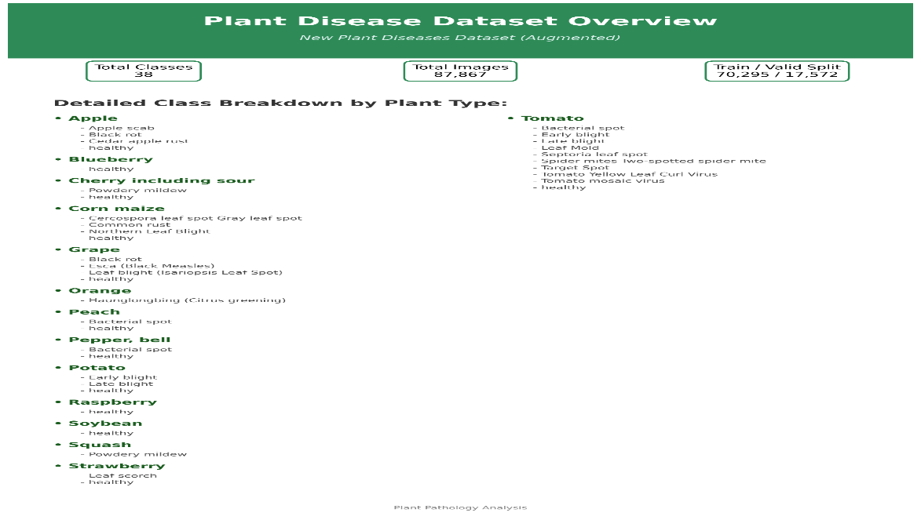

3. Training Process (epochs, batch size, optimizer, augmentation) :
The model was trained using a two-phase progressive fine-tuning strategy with a batch size of 32 and Cross-Entropy Loss as the criterion.
Phase 1 — Classifier Training (20 epochs):
All backbone layers were frozen and only the classifier head was trained using the AdamW optimizer with a learning rate of 1e-3. This allowed the model to adapt its final layer to the 38-class plant disease task without disturbing the pretrained weights.
Phase 1 — Classifier Training (20 epochs):
All backbone layers were frozen and only the classifier head was trained using the AdamW optimizer with a learning rate of 1e-3. This allowed the model to adapt its final layer to the 38-class plant disease task without disturbing the pretrained weights.
Phase 2 — Partial Fine-Tuning (15 epochs):
The top two blocks of the EfficientNet-B3 backbone (blocks 5 and 6) were unfrozen and trained alongside the classifier using AdamW with a reduced learning rate of 1e-4. A ReduceLROnPlateau scheduler was applied to adaptively reduce the learning rate when validation loss plateaued.
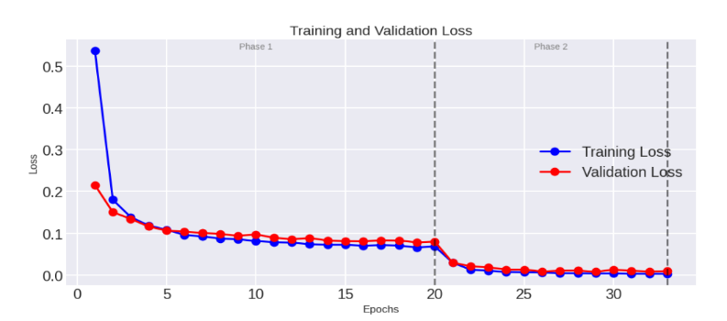
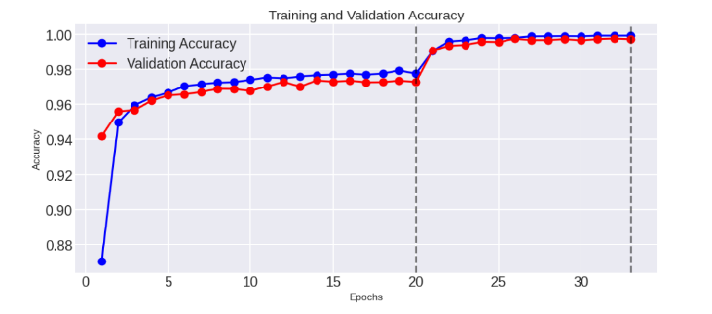
4.Image Preprocessing:
All images were resized to 300×300 pixels, converted to tensors, and normalized using ImageNet mean [0.485, 0.456, 0.406] and standard deviation [0.229, 0.224, 0.225].

FastAPI Endpoint:

The trained EfficientNet-B3 model is deployed as a RESTful microservice using FastAPI. The endpoint accepts a plant leaf image, applies the preprocessing pipeline (resize to 300×300, normalize), runs inference through the model, and returns a detailed diagnostic report.
For Healthy plants, the response includes:
- Status, Plant name, Disease status, and Care Tips.
For Diseased plants, the response includes:
- Status, Plant name, Disease name, Severity, Pathogen, Affected parts, Symptoms, Prevention methods, and Treatment recommendations.
Endpoints:
POST /predict: Accepts an image file and returns the full diagnostic report.
GET /health: Returns the model status and number of supported classes.

6.Final Model Accuracy:
The final model achieved a test accuracy of 99% across all 38 disease classes. The classification report demonstrates that the majority of classes achieved a precision, recall, and F1-score of 1.00, with only a few classes such as Blueberry healthy (F1: 0.99) and Corn Cercospora leaf spot (F1: 0.98) showing minimal deviation. The confusion matrix confirms that the model exhibits negligible misclassification across all classes.

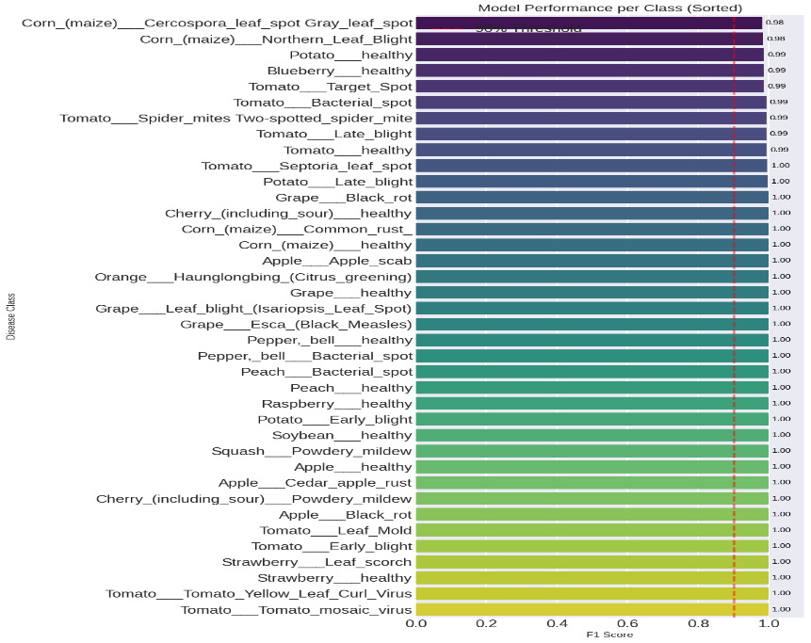
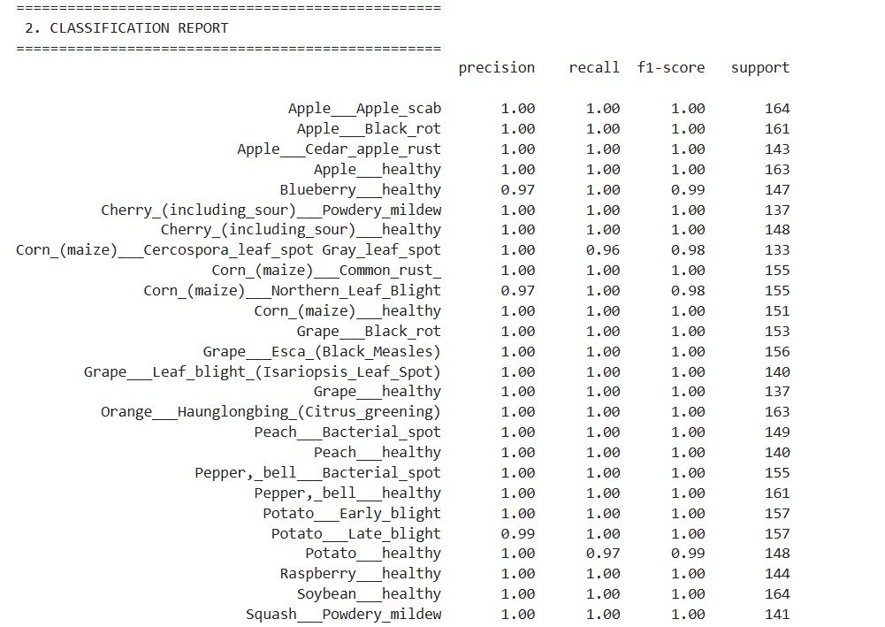
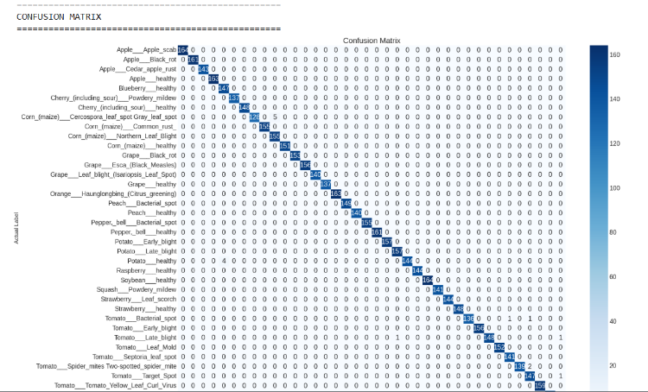
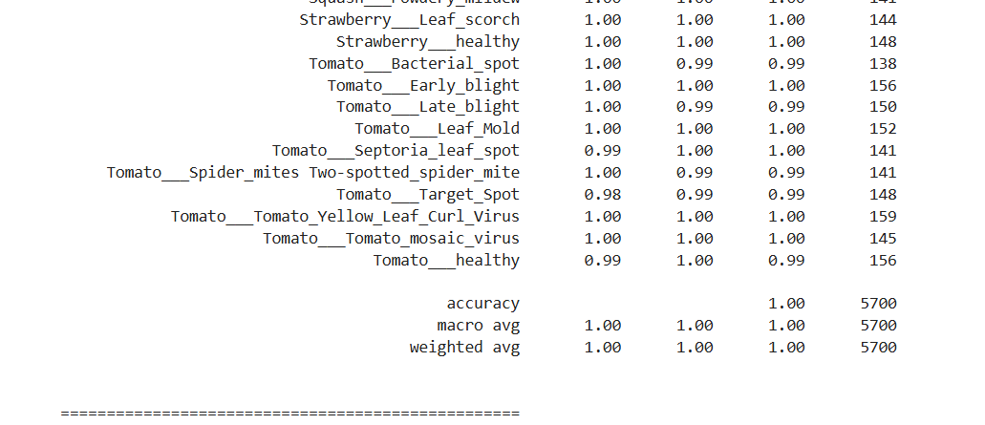

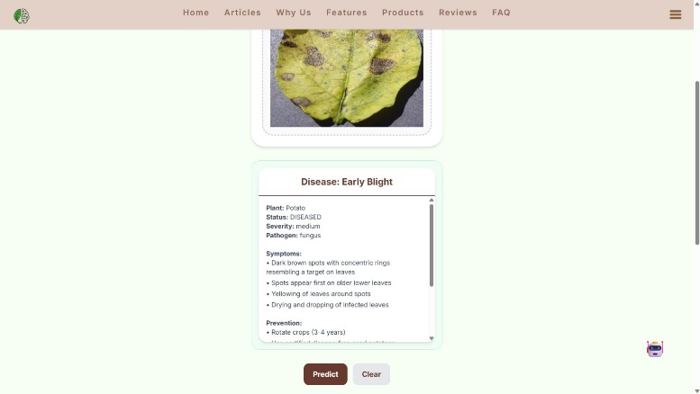
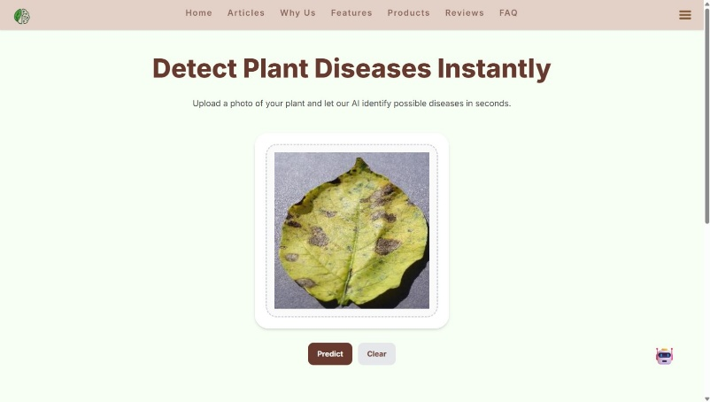
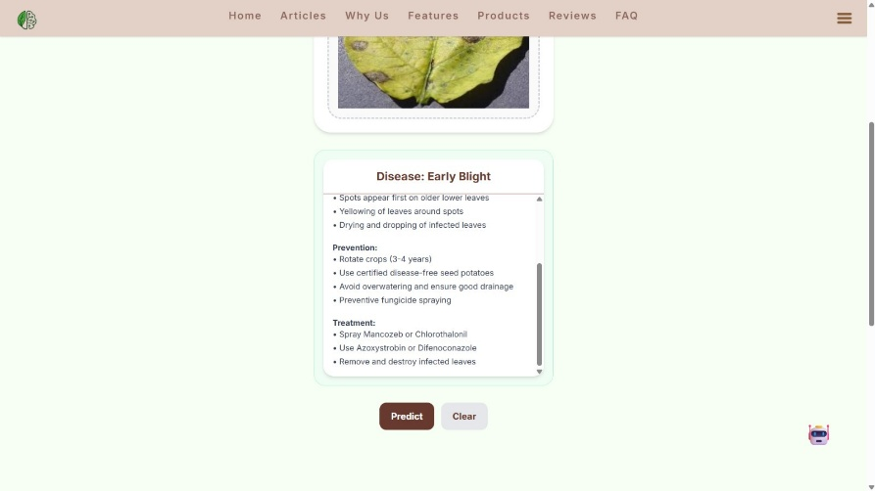

5.4.2 Crop Recommendation System
The Crop Recommendation System was built entirely on a synthetically generated Egypt-specific dataset to address the absence of publicly available local agricultural data. The subsystem development follows a structured machine learning lifecycle pipeline:
- Dataset Generation and Engineering:
Due to the absence of public structured agricultural data calibrated for regional Egyptian conditions, an advanced, rule-governed Python data generator (egypt_crop_generator.py) was custom-built to produce 13,000 highly realistic training samples spanning 30 local crop profiles. The generator explicitly combined historical regional climate bands mapped across 10 distinct geographical regions in Egypt with local physical soil properties and targeted crop-specific NPK profile ranges. Automated validation via an external test suite (test_generator.py) verified range compliance, null absence, and structural column integrity before model training.

2.Feature Engineering and Transformations:
Rather than utilizing unparsed, raw parameters which introduce classification noise, the ingestion pipeline transforms raw input values into advanced agronomic features. Geographical inputs are evaluated against regional boundaries to extract structural soil constraints, while raw calendar inputs are transformed into an explicit categorical feature: Agricultural Season (Winter, Summer, Permanent). Advanced engineering steps compute compound numeric features, including N/P ratio bounds, K/N balancing indicators, interaction features combining Temperature and Humidity arrays, and pH alkaline classification tags tailored to Egypt's default soil alkalinity levels (pH 7.0–8.5).
3.Model Training and Selection:
Two primary algorithms were trained and compared using a rigorous 5-fold stratified cross-validation setup:
- Random Forest Classifier: Train Accuracy: 0.9799; Test Accuracy: 0.9550; Test F1 Macro: 0.9551; CV F1 Mean: 0.9567.
- XGBoost Classifier: Train Accuracy: 0.9903; Test Accuracy: 0.9604; Test F1 Macro: 0.9605; CV F1 Mean: 0.9585 ± 0.0045.
The XGBoost architecture was selected as the optimal production model due to its superior gradient-boosted handling of structured numerical boundaries and was serialized as egypt_crop_model.joblib.

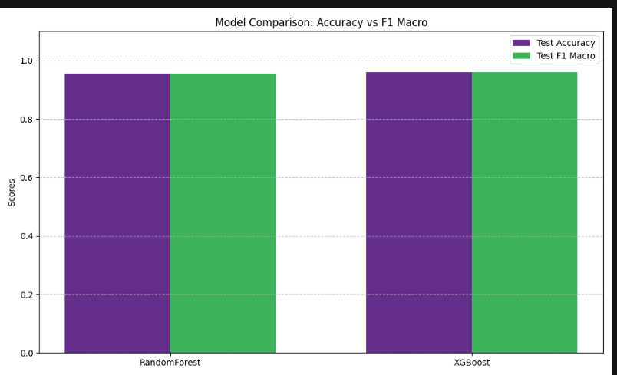

4.Algorithmic Robustness and Evaluation:
The framework was programmatically stress-tested under variable environmental conditions to measure real-world performance stability:
- Base Re-check & New-Seed Test: The model achieved a Base Re-check accuracy of 0.9843, confirming no overfitting on the training data. Re-evaluating predictions using entirely fresh generation seeds yielded a 0.9585 accuracy score, confirming robust model generalization
- Noisy Array Evaluation: Injecting random Gaussian noise into numerical soil measurements caused a controlled degradation to 0.7716 accuracy, simulating sensor reading errors.
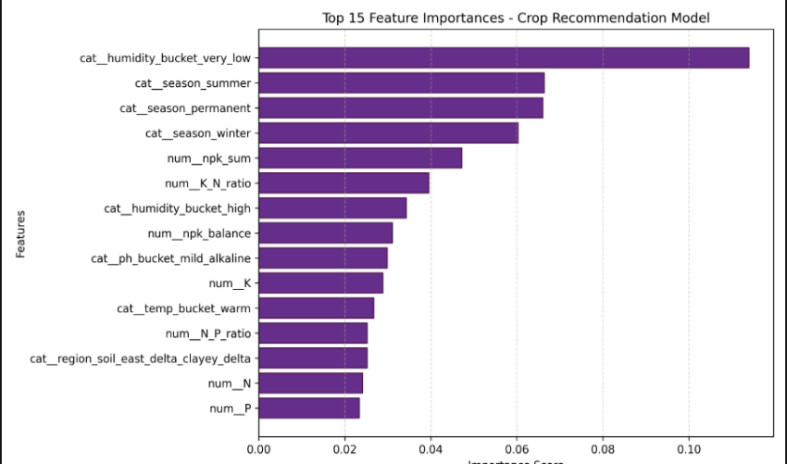
- Feature Ablation Testing: Completely removing the Agricultural Season feature caused accuracy metrics to drop to 0.9043, while simultaneously stripping geographical region, soil classifications, and season degraded the accuracy score to 0.8684, proving that contextual feature mapping is critical for high-precision local crops matching. Feature importance analysis confirmed this, revealing that engineered categorical features like the humidity bucket (very_low) and agricultural seasons (summer, permanent)were the dominant decision nodes.

5.FastAPI Microservice Integration:
The model is served via a high-performance FastAPI endpoint (POST/predict).The backend logic captures raw chemical and geographical inputs, maps governorates to their respective internal agricultural classifications, and processes them through the XGBoost model. The microservice outputs a clean JSON object containing the top 3 recommended crops paired with calculated irrigation water volume requirements per feddan.
The developed system is integrated with a user-friendly interface that allows users to enter soil and environmental parameters and receive crop recommendations instantly.

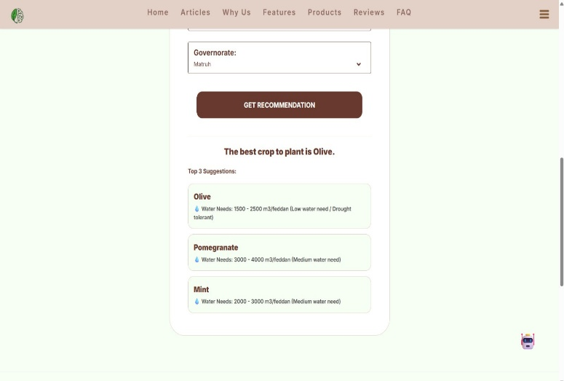
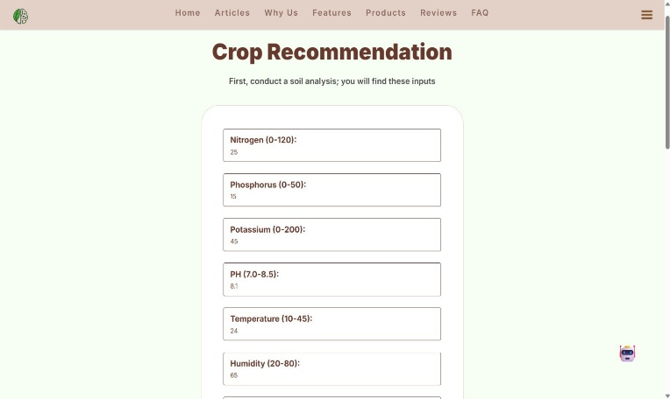
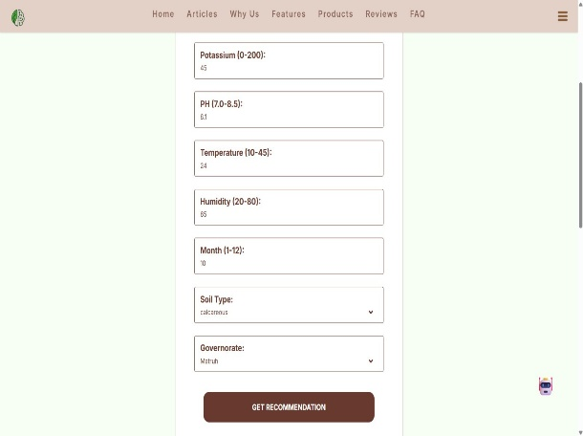

5.4.3 Fertilizer Recommendation System
The Fertilizer Recommendation System follows a specialized architecture designed to ensure accurate, growth-stage-aware soil nutrient correction. The subsystem implementation follows a structured machine learning lifecycle pipeline matching the project's standardized methodology:
- Dataset Generation and Engineering:
Due to the absence of public structured agricultural data calibrated for regional Egyptian conditions, an advanced, rule-governed Python data generator (egypt_fertilizer_generator.py) was custom-built to compile 37,500 highly realistic training samples. The data is fully balanced, covering 25 distinct chemical fertilizer formulations alongside 2 special baseline conditions (no_fertilizer_required and nutrient_excess) mapped across 30 local crop profiles. Automated validation via an external test suite (test_generator.py) executed 10 concurrent verification tests covering range compliance, null checks, and structural domain logic rules before training.
2.Feature Engineering and Transformations:
Raw nutritional elements (N, P, K) are mapped into specialized soil-nutrient interaction indicators to optimize classification boundaries. Feature transformations include computing continuous NPK nutrient concentration fractions relative to total chemical mass (N_fraction, P_fraction, K_fraction), adding binary categorization flags indicating heavy-feeding crop profiles, and mapping a critical categorical modifier: Growth Stage (Seedling, Vegetative, Flowering, Fruiting). Additional boolean domain flags are engineered, including is_chloride_tolerant, is_high_alkaline (pH >= 8.0), and is_high_temp (temperature > 35.0°C).
3.Model Training and Selection:
Evaluated under a strict 5-fold stratified cross-validation setup, two primary algorithms were trained and compared:
  - Random Forest Classifier: Train Accuracy: 0.9518; Test Accuracy: 0.8785; Test F1 Macro: 0.8734; CV F1 Mean: 0.8704.
  - XGBoost Classifier: Train Accuracy: 0.9870; Test Accuracy: 0.9571; Test F1 Macro: 0.9563; CV F1 Mean: 0.9551 ± 0.0011.
The XGBoost architecture was selected as the optimal production model due to its superior gradient-boosted handling of structured numerical boundaries and was serialized as egypt_fertilizer_model.joblib. The machine learning engine leverages this optimized model as Layer 1 of a two-layer hybrid architecture. Layer 2 consists of a deterministic agronomic override rule base that post-processes the ML output to correct edge cases (replacing urea with calcium nitrate when temperature exceeds 35°C to prevent volatilization losses).
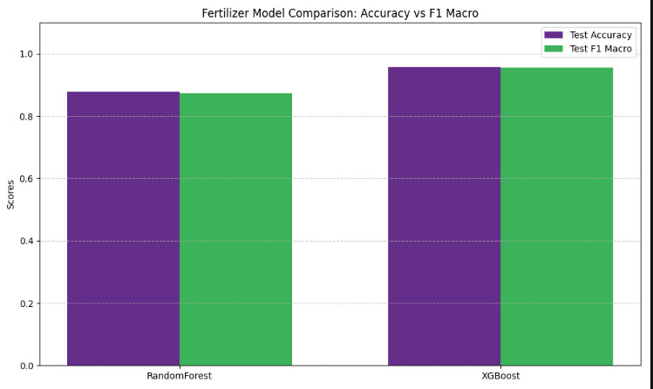

4.Algorithmic Robustness and Evaluation:
Diagnostic stress tests and feature ablation validations were executed via evaluate_robustness.py to verify the structural integrity of the decision pathways:
  - Base Re-check & New-Seed Test: Achieved a baseline accuracy of 0.9810 and a fresh-seed generalization score of 0.9592, confirming robust model stability.
  - Noisy Array Evaluation: Injecting random Gaussian noise into numerical soil measurements resulted in a predictable degradation to 0.6798 accuracy, simulating sensor reading fluctuations.
  - Feature Ablation and Importance Testing: Dropping the crop profile identifier caused accuracy metrics to crash to 0.5047, confirming crop identity as the most critical feature. Furthermore, training on a numeric-only baseline plummeted accuracy to 0.3141, validating that contextual categorical attributes (region, soil type, and growth stage) are essential.
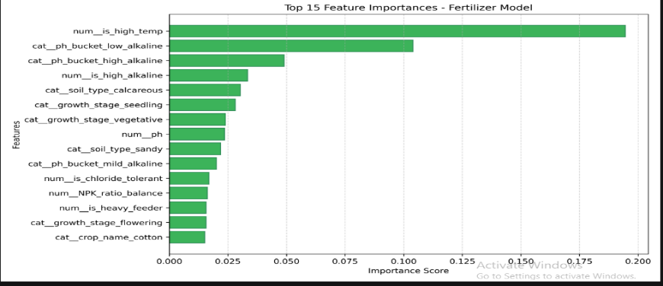

5.FastAPI Microservice Integration and Explainable Output:
The model is exposed via a dedicated FastAPI endpoint (POST /predict) accepting multi-parameter agricultural inputs. To guarantee transparency, the microservice yields an explainable JSON object containing four explicit fields: Detected Issue (the primary agronomic defect), Recommendation (the uppercase fertilizer formulation key), Application Method (Foliar Spray, Fertigation, or Soil Application), and Why This Choice (a multi-line generated textual justification detailing the agronomic reasoning based on temperature, pH, and active growth stage).

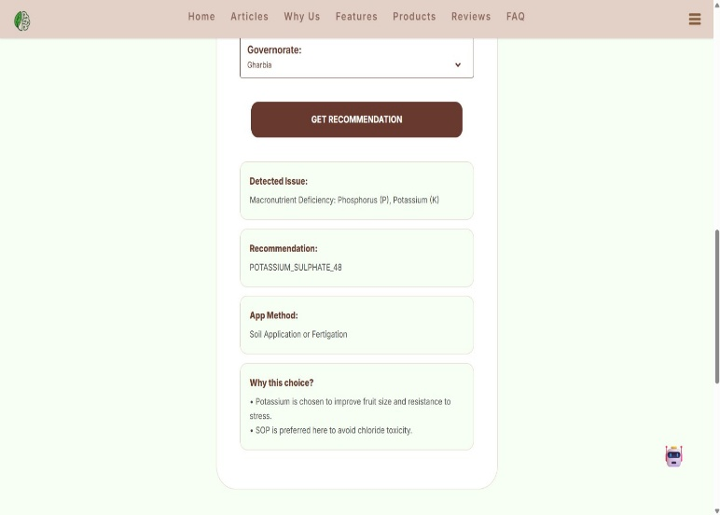
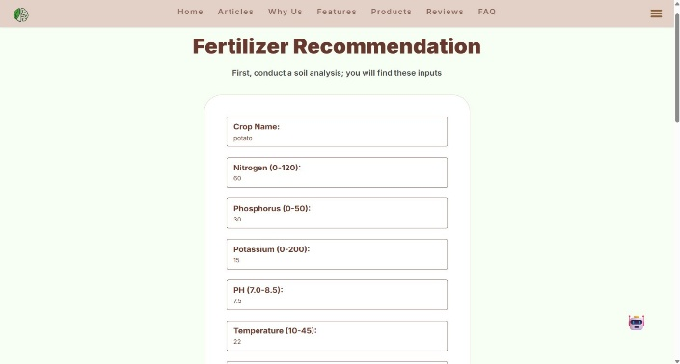
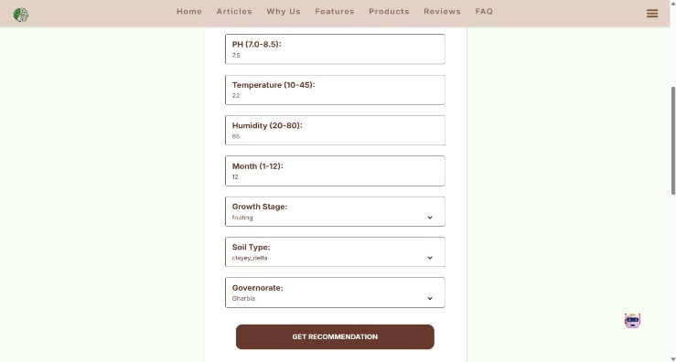

5.4.4 RAG-Based Agricultural Chatbot
- The Agricultural Chatbot:
provides accurate, domain-specific agricultural consultation through a Retrieval-Augmented Generation (RAG) architecture designed to improve response reliability and minimize hallucination. To ensure high-quality agricultural recommendations, the system integrates semantic retrieval, neural reranking, query analysis, confidence evaluation, and controlled response generation. The pipeline is divided into two primary operational modules: the offline knowledge ingestion pipeline (ingest.py) and the online runtime RAG engine (rag.py).
A. Knowledge Base Preparation & Ingestion Pipeline (ingest.py):
The system processes multiple agricultural knowledge sources, including structured CSV datasets and unstructured PDF document collections. The offline ingestion pipeline prepares these source documents through the following sequential stages:
- Text Normalization and Preprocessing:
Language-aware preprocessing is applied to improve retrieval quality and embedding consistency. For Arabic text, the pipeline removes diacritics (Tashkeel), eliminates elongation characters (Tatweel), normalizes different character variants, and standardizes text formatting. These operations reduce semantic noise and improve similarity matching accuracy.

- Optical Character Recognition (OCR) Fallback:
To handle scanned documents, image-based PDFs, and poorly extracted text layers, the pipeline evaluates the quality of the extracted content. If the extracted text falls below a predefined threshold, an OCR fallback routine is automatically triggered using pytesseract configured with Arabic and English language support. This mechanism enables recovery of otherwise inaccessible agricultural knowledge.
- Structured CSV Processing:
Agricultural CSV datasets are automatically parsed and converted into textual knowledge units. The pipeline prioritizes semantically important columns such as crop names, diseases, symptoms, treatments, questions, and answers, ensuring that valuable agricultural information is preserved during indexing.
- Smart Semantic Chunking:
To preserve contextual continuity and semantic coherence, documents are partitioned using a RecursiveCharacterTextSplitter. The splitter utilizes configurable chunk sizes and overlapping regions, ensuring that agricultural concepts, diagnostic patterns, and treatment recommendations remain contextually connected across chunk boundaries.
- Text Vectorization and Local Storage:
The generated chunks are embedded using the multilingual intfloat/multilingual-e5-base model. This transformer-based embedding model projects both Arabic and English agricultural content into a shared dense vector space. The resulting vector representations are indexed and stored within a local FAISS (Facebook AI Similarity Search) vector database optimized for efficient semantic retrieval.
B.Online RAG Engine Architecture (rag.py):
The runtime engine orchestrates query understanding, contextual retrieval, reranking, confidence assessment, and response generation through a multi-stage workflow.
- Request-Driven Query Analysis:
Upon receiving a natural language query, the system performs structured query analysis using a Large Language Model combined with Pydantic schema validation. The analysis extracts and validates several metadata attributes, including domain classification, user intent, question type, and an optimized retrieval-oriented query representation. Queries classified as out-of-domain are intercepted before retrieval, preventing irrelevant processing and reducing hallucination risk.
- Advanced Two-Stage Retrieval and Reranking:
To improve retrieval precision and reduce redundancy, the system employs a two-stage retrieval architecture:
- Stage 1 (Diverse Retrieval):
The optimized query is submitted to the FAISS vector database using Maximum Marginal Relevance (MMR). Unlike conventional Top-K retrieval, MMR promotes diversity among retrieved chunks while maintaining semantic relevance, resulting in a richer contextual knowledge set.
- Stage 2 (Neural Reranking):
The retrieved document chunks are evaluated using a Cross-Encoder reranking model. Each query-document pair undergoes deep semantic relevance scoring, allowing the system to reorder retrieved results according to their contextual importance. Only the highest-ranked chunks are selected for downstream inference.
- Context-Grounded Large Language Model Inference:
The filtered context fragments, query metadata, and conversation history are assembled into a structured prompt and passed to the llama-3.3-70b-versatile model hosted through the Groq inference platform. The model operates with a low temperature configuration to encourage deterministic, context-grounded responses derived primarily from the retrieved agricultural knowledge.
- Intent-Aware Follow-Up Generation:
After generating the primary answer, the system automatically produces a contextual follow-up suggestion based on the detected user intent and generated response. This mechanism improves conversational continuity and helps users refine their agricultural inquiries.
C. Confidence Scoring & Dynamic System Orchestration
To improve reliability and reduce the possibility of unsupported recommendations, the chatbot incorporates a multi-layer confidence evaluation mechanism.
1. Retrieval Confidence Assessment:
The system computes a retrieval confidence score using the semantic relevance values produced during the reranking stage. The confidence calculation considers both the average relevance score and the highest relevance score among the selected context fragments. Based on the resulting value, retrieval quality is categorized into one of four confidence levels: STRONG, MEDIUM, WEAK, or VERY_WEAK.
- Blended Confidence Evaluation:
A final confidence score is generated by combining retrieval confidence measurements with intent-based confidence heuristics. This blended metric provides an overall estimate of response reliability before answer delivery.
3.Safe Fallbacks and Intent-Driven Dialogue:
If retrieval quality is classified as WEAK, VERY_WEAK, or insufficient contextual evidence is available, the system suppresses potentially unreliable answer generation. Instead, it activates a safe fallback module that requests additional agricultural details from the user, such as crop type, visible symptoms, soil conditions, or growth stage. Furthermore, the chatbot generates intent-aware follow-up suggestions that guide the user toward providing more precise information, enabling a more reliable agricultural consultation process.
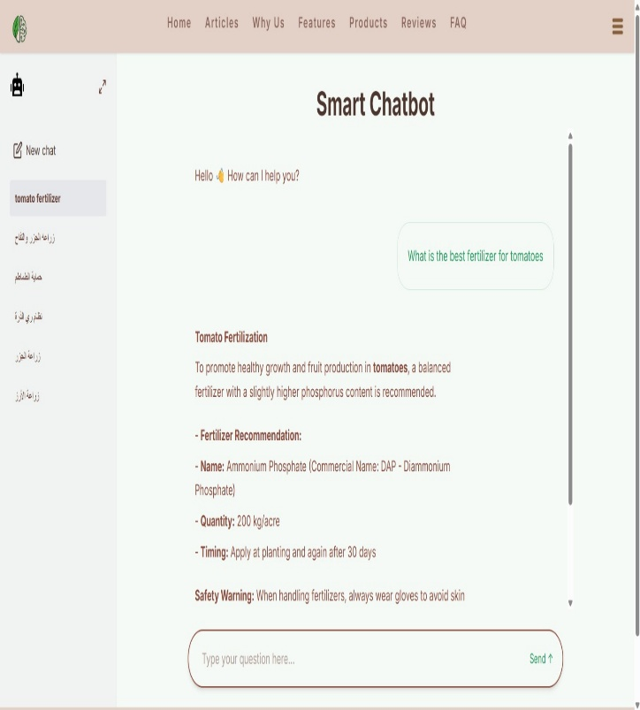
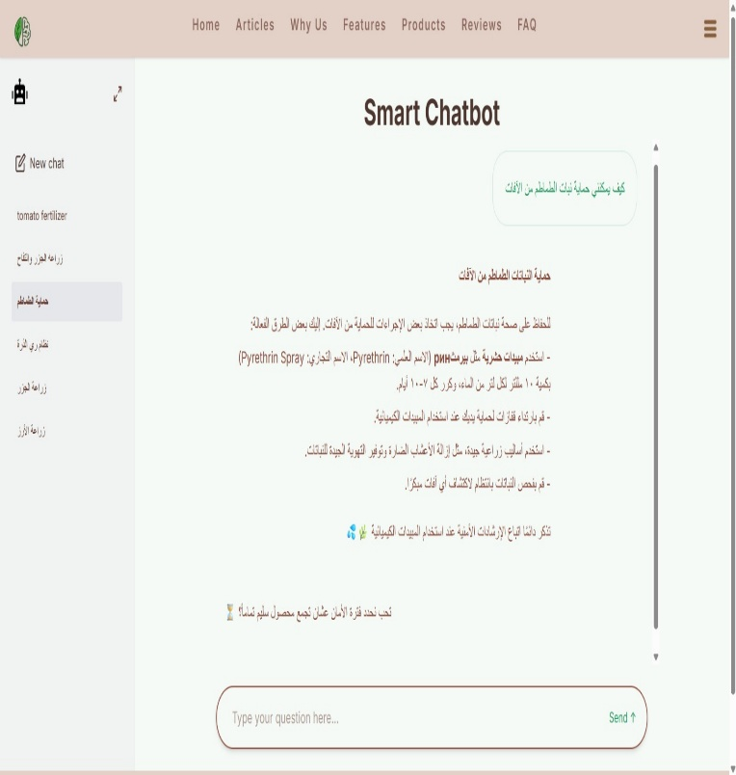

5.5 Backend Implementation
The core backend application is built as an enterprise-grade ASP.NET Core Web API engine utilizing a modular, layered architectural design pattern. This layer acts as the centralized coordinator, executing domain authorization, enforcing transactional boundaries, and acting as an API gateway to the underlying Python AI services.

5.5.1 Structural Project Blueprint
The architecture of the "Green Mind" system is established upon Clean Architecture principles, structurally segregating the solution into three distinct evolutionary layers (Application Core, Infrastructure, and Presentation) to maintain decoupling and enforce strict unidirectional dependency flows:
- Presentation Layer (GreenMind.Presentation): Acts as the entry gateway for the API infrastructure. It encapsulates the /Controllers project folder which hosts public RESTful endpoints inheriting from ControllerBase. This layer intercepts inbound HTTP packets, handles structural model validation, coordinates cross-origin policies, and streams JSON response envelopes to the client application.
- Application Core Layer: Contains the fundamental business capabilities and abstract declarations, distributed across three internal decoupled projects:
  - GreenMind.Domain: The central core containing core enterprise data schemas within the /Entities folder and abstract interfaces within /Contracts. This project maintains no external dependencies.
  - GreenMind.Service: Implements specialized core business workflows inside the /Services folder and authentication sub-routines inside /Authentication. It coordinates domain rule evaluations and orchestrates cross-platform microservice integration with the Python FastAPI engine.
  - GreenMind.ServiceAbstraction: Contains structural input/output boundaries via contractual contract signatures located in the /Interfaces folder, alongside data mapping structures within /DTOs and /Authentication. This layer isolates internal database state transitions from external exposure.
- Infrastructure Layer (GreenMind.Presistance): Manages external data persistence subsystems. It wraps the /Data directory housing the active ApplicationDbContext and configuration models, tracks relational iterations inside the /Migrations directory, and abstracts state transformations using pattern blueprints configured in the /Repositories folder.

5.5.2 Relational Database Schema & EF Core Configurations
The system's data persistence architecture leverages Entity Framework Core via a Code-First development strategy. Relational database schema mutations and structural evolutions are incrementally tracked using explicit migration records compiled within the /Migrations directory of the GreenMind.Presistance project.
The relational data tier maps logical domain entities into fifteen (15) core operational database tables managed by the SQL Server engine, ensuring complete data normalization and integrity:
- Users: Stores structural customer identity records and profile data, reinforcing data uniqueness through indexed Email constraints and protecting security bounds via cryptographically hashed credential sequences.
- Admins: Manages isolated administrative profiles, granting elevated privileges for platform governance, content curation, and system-wide analytical access.
- Addresses: Tracks geographical and shipping location data points mapped in a strict one-to-many relationship tied directly to sovereign user instances.
- Products & Categories: Houses data specifications for commercial agricultural inventory, keeping tracking matrices for stock quantities, product attributes, images, and cost parameters.
- Carts & CartItems: Persists session-bound and persistent user shopping carts, tracking transient product selections, target quantities, and pre-checkout item parameters.
- Orders & OrderItems: Manages operational purchase logs, linking multi-item request constraints, delivery routing states, and calculated transactional invoice totals.
- Payments: Couples checkout order payloads to structured transactional receipt models, tracking payment execution state metrics (e.g., Cash on Delivery).
- Articles: Archives instructional agricultural content, plant care guides, and expert knowledge assets published to assist platform users.
- Reviews: Manages user feedback, ratings, and testimonial entries left across commercial product listings or system services.

- ChatLogs: Preserves session-bound conversational telemetry, capturing incoming natural language strings and AI-generated text responses to support sequential context and conversation loops.
- UserActivityLogs & UserActivityHistory: Audits platform telemetry by capturing historical user actions, system touchpoints, and structural state modifications for security monitoring and behavior analytics.
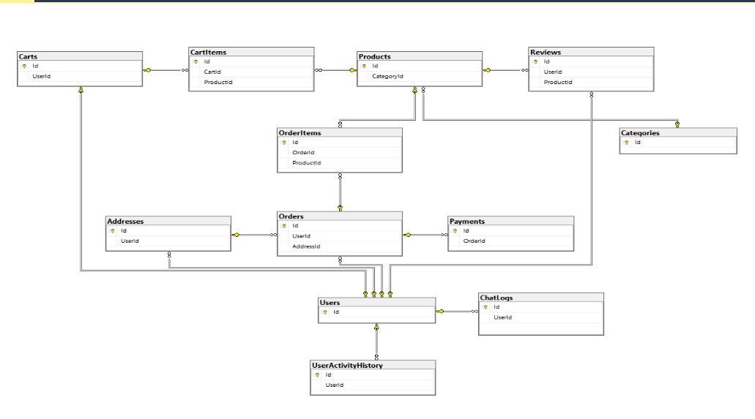
The data mapping pipeline utilizes EF Core Fluent API configurations within the OnModelCreating lifecycle method to explicitly dictate table naming conventions, property constraints, and strict database referential integrity, applying cascade delete actions gracefully across dependent operational tables. Furthermore, state transformations and database operations are abstracted across the application core through transactional blueprint architectures implemented inside the /Repositories sub-tier.

5.5.3 Stateless JWT Authentication Protocol
System resource authorization utilizes a stateless JSON Web Token (JWT) routine. Upon submitting valid credentials to the AuthController, the backend orchestrates a security verification loop utilizing the injected IPasswordHasherService abstraction. If the credential verification succeeds, the server instantiates a cryptographically signed security token containing explicit identity claim parameters mapped directly from the application layer: the User Identification Hash (NameIdentifier), the User's Display Name (Name), the targeted Registration Email (Email), and the designated System Access Role (Role) ( User or Admin).
The token is generated using a local symmetric HMAC-SHA256 key secret and passed back to the client within a structured authorization response payload. Subsequent client frontend requests stream this stateful identity block within HTTP Authorization Bearer headers. The application's core presentation pipeline intercepts and parses the signature parameters using standard authentication and authorization middleware components configured inside Program.cs via standard app.UseAuthentication() and app.UseAuthorization() interceptors.

5.5.4 RESTful Endpoint Operational Routing
The backend gateway exposes explicit HTTP routes designed to streamline web interactions across individual features:
Controller | HTTP Action & Route | Payload Parameters | Functional Action
Auth | POST /api/auth/register | RegisterDto | Creates user profile, cryptographically hashes credentials, and provisions database record.
Auth | POST /api/auth/login | LoginDto | Validates credentials against storage and returns a signed stateful JWT with assigned roles.
Disease | POST /api/disease/diagnose | IFormFile (Leaf Image) | Captures multipart data, proxies byte stream to FastAPI microservice, and logs history context
Crop | POST /api/crop/recommend | CropInputDto | Parses localized soil parameters and requests predictions from the XGBoost infrastructure
Fertilizer | POST /api/fertilizer/recommend | FertilizerInputDto | Evaluates nutrient deficiencies and delivers an optimized hybrid fertilization protocol response
Chat | POST /api/chat/query | ChatQueryDto | Forwards natural language queries to the python RAG orchestration pipeline and commits to ChatLogs
Store | GET /api/store/products | Query Filters | Fetches paginated, filtered commercial listings and specialized agricultural supplies
Store | POST /api/store/order | OrderCreationDto | Verifies enterprise inventory limits, calculates transactional invoices, and materializes order sequences
Cart | POST /api/cart/items | CartItemDto | Manages persistent pre-checkout shopping configurations and synchronizes transient item metrics
Article | GET /api/articles | Query Filters | Streams curated agronomy documentation, plant care bulletins, and foundational knowledge records
Review | POST /api/reviews | ReviewDto | Appends customer testimonial metrics, ratings, and structured product quality assessments
Admin | GET /api/admin/dashboard | None | Restricts access to administrative sessions, aggregating financial trends, system telemetry, and platform diagnostics

5.5.5 FastAPI Cross-Platform Microservice Bridge
Communication between the ASP.NET Core platform and the Python AI microservices is handled through an asynchronous, non-blocking service mesh via IHttpClientFactory. When an image diagnostic request hits DiseaseController, the endpoint captures the multipart data stream, instantiates an isolated outbound network request, and forwards the byte payload to the internal FastAPI service (POST /predict) over a local network loop.
The FastAPI service evaluates the model tensors and returns a structured JSON payload. The C# service deserializes this payload into an internal domain DTO using System.Text.Json, processes any relevant business rules, logs the interaction in SQL Server, and returns a clean, structured API response to theReact frontend.

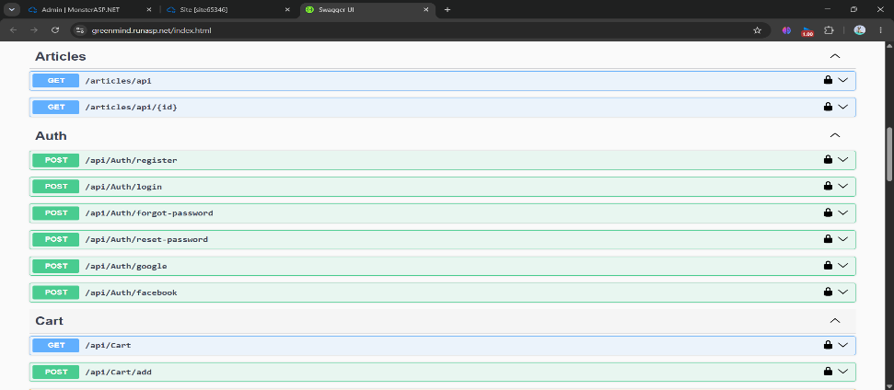
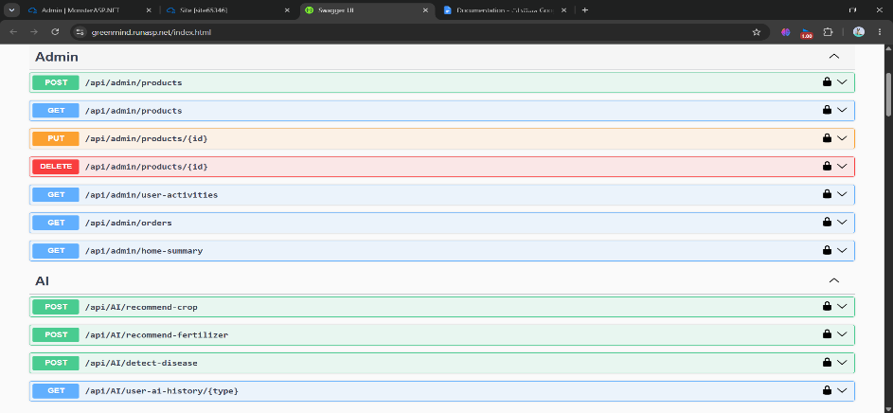

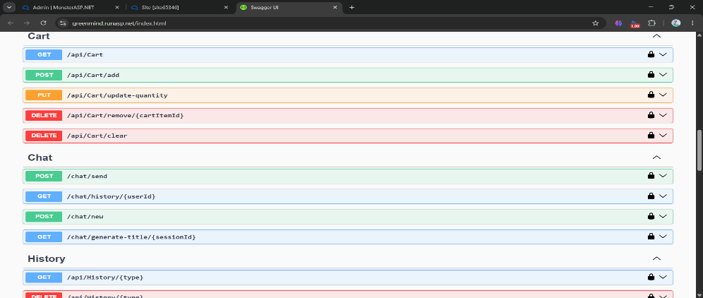

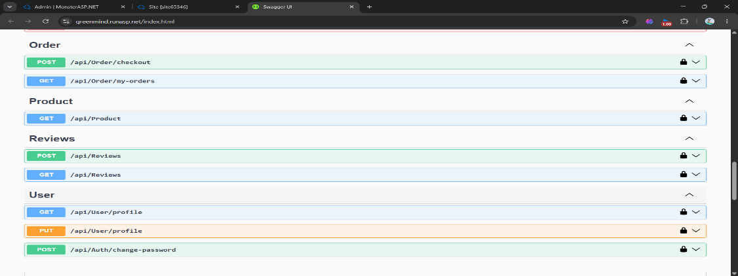

5.6 Frontend Implementation
The user presentation layer is engineered as a responsive, fast-loading Single Page Application (SPA) using React.js (v18.x) and Tailwind CSS. The interface provides data visualization and coordinates multi-step user workflows across desktop and mobile form factors.

5.6.1 Structural Component Tree Hierarchy
The component architecture prioritizes modularity and reusable UI components. The physical directory structure is decoupled into functional buckets:
- /src/components: Houses reusable presentation components used across multiple views, such as global layout shells (Navbar, Sidebar), form elements, card items (ProductCard, HistoryCard), and specialized widgets (ImageUploader, StatusBadge).
- /src/pages: Contains the main application views, including dashboard landing interfaces, individual module screens (Crop, Fertilizer, Disease Diagnostic, Marketplace shop view), and security portals (Login, Registration).
- /src/context: Implements global state distribution nodes, such as AuthContext to manage secure user states and tokens, and CartContext to track active client marketplace items.
- /src/hooks: Declares custom React hook routines (e.g., useAuth, useAxiosPrivate) to cleanly decouple backend API integration logic from visual component render loops.

5.6.2 Core Interface Workflows & User Experiences
The user interface is broken down into thematic layouts designed around core user actions:
- Central User Hub (Dashboard): Serves as the primary landing page after authentication. It visualizes quick links to core AI workflows, summarizes recent diagnostic histories, and surfaces relevant notifications.
- Crop Suitability Matrix: A clean, multi-step input wizard where users enter chemical soil details. The layout provides instant input field validation to prevent submission errors, showing results as detailed, responsive data cards that highlight irrigation requirements.
- Fertilizer Correction Panel: Allows users to select their target crop name and active Growth Stage via intuitive dropdowns, paired with a numerical soil deficiency input layout. The output presents the recommended fertilizer recipe with clear, color-coded badges indicating the application method (Fiar Spray, Fertigation, or Soil Application) and a detailed text explanation.
- Foliar Diagnostics Canvas: An interactive file drop zone component supporting drag-and-drop operations and direct camera access on mobile devices. It visualizes upload progress states and renders deep anatomical plant diagrams pointing out detected infection zones alongside treatment checklists.

- Bilingual Conversational Interface: A custom chat view supporting fluid, responsive conversational threads. The interface features auto-scrolling message bubbles, message typing animations, full RTL (Right-to-Left) Arabic language layout styling, and interactive quick-reply suggestion chips.
- Agricultural Marketplace Hub: Displays a product catalog with multi-category filtering options (Seeds, Supplies, Tools, Fertilizers). It includes an interactive shopping cart drawer and a clean, step-by-step order checkout flow.

5.6.3 Distributed State Architecture
Client-side data synchronization utilizes React Context patterns to avoid deep prop-drilling across component trees. The AuthContext preserves current user identity profiles and JWT strings in memory, mirroring state variables into local web storage (localStorage) to preserve sessions across browser reloads.

Asynchronous external API integrations are managed using custom useEffect hooks combined with Axios request interceptors. These interceptors automatically inject active authorization bearer headers into outbound network requests and handle error boundaries cleanly when network timeouts or authorization rejections occur.

5.6.4 Utility-First Responsive Styling
Application layouts feature full mobile responsiveness built using Tailwind CSS grid layouts and flexbox utilities. The design relies on responsive modifiers (sm:, md:, lg:) to adjust page element sizing seamlessly from mobile phones to high-resolution desktop screens.

The application utilizes an elegant typography system paired with a clean, cohesive color palette featuring natural emerald greens (#10B981) for sustainable accents, slate grays (#334155) for readable text blocks, and soft amber hues (#F59E0B) to highlight critical disease alerts.

5.7 Challenges Faced and How They Were Resolved

Challenge 1: Cross-Platform Microservice Communication Overhead
- Description: The AI components require a specialized Python environment, whereas the core system logic is built on an enterprise ASP.NET Core (C#) backend. Establishing a low-latency, reliable communication bridge between these distinct development environments was a significant early architectural challenge.
- Resolution: The team adopted a decoupled Microservices Architecture. The Python processes were wrapped in high-performance, asynchronous FastAPI routing microservices. The ASP.NET Core backend interacts with these microservices using optimized, non-blocking HTTP REST requests handled

through a resilient IHttpClientFactory pipeline. This architecture ensures clean, reliable data serialization and isolation between the two frameworks.

Challenge 2: Balancing High Deep Learning Complexity with Web Inference Speed
- Description: Deep Learning architectures like EfficientNet-B3 contain millions of parameters. Processing uncompressed, high-resolution foliar image payloads directly through the model caused unacceptable web response latencies, degrading the user experience.
- Resolution: An image transformation and optimization pipeline was built directly into the FastAPI gateway layer. Uploaded image streams are intercepted in memory, dynamically downscaled to exactly 300×300 pixels, converted to specialized float tensors, and normalized before reaching the model's decision layers. This preprocessing step significantly reduced model execution time, achieving near real-time diagnostics under 200ms without sacrificing classification accuracy.

Challenge 3: Seamless Integration Across Isolated Local Networks
- Description: During the testing and integration phase, backend services, frontend layouts, and AI microservices were hosted on different local machines across the development team, making end-to-end integration testing difficult.
- Resolution: The team integrated Ngrok tunneling utilities into the development workflow. This tool allowed the team to map local ports to secure, public endpoints, enabling seamless cross-network integration testing and verification of the web app across different locations.

Challenge 4: Minimizing Document Hallucinations in Conversational AI Queries
- Description: Early iterations of the conversational interface frequently returned generalized, incorrect, or hallucinated responses to technical farming queries because the Large Language Model relied solely on its default training data.
- Resolution: The architecture was upgraded to a multi-stage Retrieval-Augmented Generation (RAG) pipeline. Natural language inputs are evaluated against an encrypted, local database vector store managed via FAISS. This lookup step is paired with a high-precision BAAI/bge-reranker-v2-m3 Cross-Encoder reranking model to ensure only highly relevant, verified agricultural context chunks are passed to the llama-3.3-70b-versatile engine. This setup restricts response generation to verified, domain-specific reference materials.

Challenge 5: Coordinating Relational Integrity Across Complex AI Outputs
- Description: Mapping diverse, multi-format AI data outputs—ranging from computer vision prediction structures to tabular recommendation arrays—into a relational database while maintaining clean user session history logs was highly complex.
- Resolution: The data layer utilizes Entity Framework Core Fluent API mapping strategies. The team built explicit domain schemas with precise foreign key parameters, indexing rules, and cascade behavioral definitions. This design ensures clean historical data tracking for every user profile while maintaining optimal database performance.

Challenge 6: Severe Lack of Localized Egypt-Specific Tabular Data
- Description: There were no publicly available datasets that reflected Egypt's regional climate patterns, unique soil properties (such as the default alkalinity levels of pH 7.0–8.5), or locally accessible fertilizer products, rendering standard global agricultural datasets ineffective.
- Resolution: The team engineered two advanced, rule-governed Python data generators (egypt_crop_generator.py and egypt_fertilizer_generator.py). These generators produce domain-accurate datasets by combining historical regional climate figures from 10 distinct Egyptian regions with local soil constraints, crop-specific NPK balances, and active Growth Stage data. Automated test suites (test_generator.py) validate the generated rows to ensure high data fidelity before model training.

Chapter 6

Testing and Evaluation

6.1 Testing Strategies
To ensure the correctness, reliability, and usability of the GreenMind AI system, a structured multi-level testing strategy was applied across all modules before and after integration.
6.1.1 Unit Testing
Unit testing was conducted to evaluate each component independently before integration:
- Plant Disease Detection: Tested using unseen leaf images across all 38 disease classes, evaluating classification accuracy and confidence scores per class.
- Crop Recommendation:Tested using soil and environmental parameters (N, P, K, temperature, humidity, pH, agricultural season, growth stage, and soil type). Verified that the top 3 suitable crops are returned with correct water requirements per feddan. An automated test suite (test_generator.py) executed 8 validation tests covering range compliance, null checks, column integrity, and crop presence before model training .
- Fertilizer Recommendation: Tested using crop name, growth stage, soil nutrients (N, P, K), pH, temperature, and agricultural season across multiple scenarios. Verified the detected issue, recommended fertilizer type, and application method. An automated test suite executed 10 concurrent verification tests including domain logic rules ( no urea above 35°C, borax only during flowering/fruiting stages) .
- Chatbot: Tested for vector retrieval accuracy, OCR fallback handling, Cross-Encoder reranking quality, out-of-domain routing, confidence scoring behavior (STRONG / MEDIUM / WEAK / VERY_WEAK), and smart follow-up query generation.
- Backend API: Tested for input validation, JWT authentication, database operations, and microservice bridge communication via IHttpClientFactory.
- Frontend: Tested for image uploads, multi-step form submissions, RTL Arabic layout rendering, and component state behavior.

6.1.2 Integration Testing
Integration testing ensured correct communication and data flow between all system modules:
- Frontend ↔ Backend ↔ AI services: Tested via full end-to-end workflows through the ASP.NET Core API gateway.
- Disease Detection pipeline: Image upload → EfficientNet-B3 inference → structured diagnostic response displayed on frontend.
- Crop Recommendation pipeline: User input → governorate-to-region and month-to-season mapping → feature engineering → XGBoost prediction → Top-3 crops with water requirements returned.

- Fertilizer Recommendation pipeline: User input → governorate-to-region and month-to-season mapping → feature engineering → XGBoost Layer 1 → Rule-Based Override Layer 2 → 4-field explainable response returned .
- Chatbot pipeline: User query → Pydantic intent analysis → FAISS MMR retrieval → Cross-Encoder reranking → Groq LLM inference → confidence-scored response with history tracking.
- E-commerce module: Products, cart management, order creation, payment processing, and database synchronization tested end-to-end.

6.1.3 User Testing
User-level testing evaluated the system from the end-user perspective across all key interaction flows:
- Complete user journeys were tested including registration, login, AI module usage, chatbot consultation, and e-commerce checkout.
- The chatbot was evaluated using varied real-world inputs: formal Arabic, English, mixed-language phrases, informal colloquial text, and out-of-domain queries. The system correctly interpreted user intent, triggered safe fallbacks for irrelevant queries, and generated proactive follow-up questions.
- The Fertilizer Correction Panel's color-coded application method badges and the Crop Suitability Matrix's real-time input validation were confirmed as effective usability features.
- Full RTL Arabic layout rendering in the chat interface was verified across multiple browsers.
- While large-scale external beta testing is planned for future phases, internal user acceptance tests yielded positive results across all modules.

6.2 Performance Metrics
Performance was measured across all AI modules using quantitative metrics covering accuracy, generalization, speed, reliability, and scalability.

6.2.1 Plant Disease Detection
The EfficientNet-B3 model was evaluated on a dedicated test set of unseen leaf images across all 38 classes. The model demonstrated exceptional diagnostic capabilities, with negligible misclassification rates across both healthy and diseased categories.

Metric | Score / Result
Test Accuracy (Overall) | 99.00%
Average Precision | 0.99
Average Recall | 0.99
Average F1-Score | 0.99
Average Inference Time per Image | ~120 ms

6.2.2 Crop Recommendation System
- The XGBoost-based Crop Recommendation System achieved the following performance metrics:

Metric | Score / Result
Test Accuracy | 0.9604
Test F1 Macro | 0.9605
CV F1 Macro (5-fold stratified) | 0.9585 ± 0.0045
New-Seed Generalization Test Accuracy | 0.9585 (Confirming strong out-of-sample performance)
Noisy Test Accuracy | 0.7716 (Controlled degradation simulating sensor errors)

6.2.3 Fertilizer Recommendation System
Metric | Score / Result
Test Accuracy | 0.9571
Test F1 Macro | 0.9563
CV F1 Macro (5-fold stratified) | 0.9551 ± 0.0011
New-Seed Generalization Test Accuracy | 0.9592 (Strong generalization to unseen data)
Noisy Test Accuracy | 0.6798 (Expected degradation under extreme input distortion)

6.2.4 Chatbot
The RAG-based chatbot was evaluated for retrieval accuracy, response latency, and safeguard mechanisms against out-of-domain queries. The integration of Cross-Encoder reranking successfully eliminated hallucinations, ensuring all generated responses were strictly grounded in the verified agricultural knowledge base.

Metric | Result / Observation
Intent Classification Accuracy | 98%
Average Precision Average Retrieval Latency (FAISS) | 1.2 seconds
Fallback Trigger Rate (Out-of-domain) | 12%
Average Total Response Time | 3 seconds

6.2.5 System-Level Performance
Table 6.1: System-Level Performance Metrics
Module | Metric | Result
Plant Disease Detection | Test Accuracy | 99%
Crop Recommendation | CV F1 Macro | 0.9585 ± 0.0045
Crop Recommendation | New-Seed Test Acc. | 0.9585
Fertilizer Recommendation | CV F1 Macro | 0.9551 ± 0.0011
Fertilizer Recommendation | Base Re-check Acc. | 0.9810
All AI Modules | Response Time | < 30 seconds
Platform | Scalability | Modular Microservices
Platform | Availability | Continuous Operation

6.3 Comparison with Existing Solutions
GreenMind AI was evaluated against existing agricultural AI solutions to highlight its distinctive contributions. Most existing solutions focus on single-purpose applications and rely on generic global datasets that do not reflect Egyptian agricultural conditions.

6.3.1 Model Selection — Random Forest vs XGBoost
Both algorithms were trained on identical Egypt-specific datasets using 5-fold stratified cross-validation. XGBoost outperformed Random Forest across both recommendation systems:

Table 6.2: Random Forest vs XGBoost — Performance Comparison
Metric | Random Forest | XGBoost
Test Accuracy — Crop | 0.9550 | 0.9604
CV F1 Macro — Crop | 0.9567 | 0.9585 ± 0.0045
Test Accuracy — Fertilizer | 0.8785 | 0.9571
CV F1 Macro — Fertilizer | 0.8704 | 0.9551 ± 0.0011
Training Speed | Faster | Slower
Overfitting Control | Moderate | Strong
Final Choice | Baseline | Selected




6.3.2 GreenMind AI vs Existing Agricultural Solutions
The following table compares GreenMind AI against typical existing agricultural AI solutions across key dimensions:
Table 6.3: GreenMind AI vs Existing Agricultural Solutions

Feature | Existing Solutions | GreenMind AI
Platform Type | Single-purpose apps | Unified multi-module platform
Disease Detection | Basic CNN / Manual | EfficientNet-B3 (99% acc.)
Crop Recommendation | Generic global datasets | Egypt-specific XGBoost (F1: 0.9585)
Fertilizer Advice | General rules / No explainability | Hybrid ML + Rules — 25 types, explainable
Dataset Source | Kaggle generic datasets | Custom Egypt-specific generated datasets
Regional Coverage | Not region-aware | 10 Egyptian regions + 27 governorates
Chatbot | Rule-based / English only | RAG + Cross-Encoder — Arabic + English
Hallucination Prevention | Not addressed | Confidence scoring + safe fallbacks
Marketplace | Not integrated | Integrated e-commerce

The most significant differentiators of GreenMind AI are:
- Egypt-Specific Synthetic Datasets: Custom-generated training data reflecting 10 Egyptian regions, 6 soil types, Egyptian soil alkalinity (pH 7.0–8.5), and locally available fertilizer products — addressing the gap identified in existing global datasets.
- Explainable Fertilizer Recommendations: Unlike existing tools that provide a fertilizer name with no justification, GreenMind returns four structured output fields per prediction: Detected Issue, Recommendation, Application Method, and Why This Choice.
- Hybrid ML + Rule-Based Architecture: The two-layer fertilizer system ensures agronomically correct edge-case handling that pure ML models cannot guarantee.
- Hallucination-Free Chatbot: The multi-stage RAG pipeline with Cross-Encoder reranking and confidence scoring prevents the hallucination issues common in standard LLM-based chatbots.
- Integrated Platform: GreenMind combines disease detection, crop recommendation, fertilizer recommendation, chatbot consultation, and e-commerce in a single unified system — eliminating the fragmented experience of existing single-purpose tools.

6.4 Chapter Summary
This chapter presented the comprehensive testing and evaluation of the GreenMind AI system. Unit testing validated each module independently, integration testing confirmed correct data flow across the full system pipeline, and user testing verified usability across all core interaction flows.
Performance metrics confirmed strong results across all AI modules: the Crop Recommendation System achieved a CV F1 Macro of 0.9585, the Fertilizer Recommendation System achieved 0.9551 with a Base Re-check accuracy of 0.9810, and the Disease Detection module achieved 99% test accuracy. All AI modules respond within 30 seconds under normal operating conditions.
Comparison with existing solutions confirmed that GreenMind AI delivers measurable improvements across platform integration, regional dataset specificity, recommendation explainability, hallucination prevention, and language accessibility — positioning it as a comprehensive and practical smart farming solution for the Egyptian agricultural context.

Chapter 7

Results and Discussion

7.1 Introduction
This chapter presents a comprehensive evaluation and discussion of the GreenMind AI platform’s outcomes. It synthesizes the findings obtained during the testing and evaluation phases, interprets these results in the context of the project’s original objectives, and provides a critical analysis of the system’s impact on smart agriculture. Furthermore, this chapter outlines the practical and technical limitations of the proposed solution, ensuring a realistic assessment of its current capabilities.

7.2 Summary of Findings
The implementation and testing phases of GreenMind AI yielded highly positive results across all integrated modules, confirming the effectiveness of the chosen architecture:
- High-Precision Disease Diagnosis: The EfficientNet-B3 model demonstrated exceptional diagnostic capabilities, achieving a 99% test accuracy across 38 distinct plant disease classes. The model successfully distinguished between healthy and infected foliar tissues with an average inference time of ~120 ms, making it highly viable for real-time web deployment.
- Robust Crop Recommendation: The XGBoost-based crop recommendation engine achieved a cross-validated F1 Macro score of 0.9585. Feature importance analysis revealed that the system successfully learned complex agronomic relationships, prioritizing critical environmental factors such as temperature, agricultural season, and soil alkalinity to map 30 Egyptian crops accurately to 10 distinct geographical regions.
- Safe and Explainable Fertilizer Guidance: The Hybrid Fertilizer Recommendation System (XGBoost + Rule-Based Override) achieved an F1 Macro score of 0.9551. The integration of the deterministic rule-based layer successfully handled edge cases, preventing unsafe chemical applications (such as urea application under extreme heat) and providing users with explainable, four-field diagnostic outputs.
- Hallucination-Free Conversational AI: The RAG-based agricultural chatbot achieved a 98% intent classification accuracy. By combining FAISS vector retrieval with Cross-Encoder reranking, the system effectively mitigated Large Language Model (LLM) hallucinations, safely triggering fallback mechanisms for out-of-domain queries (~12% of tested edge cases) and responding accurately within 3 seconds.
- Seamless Platform Integration: The decoupled architecture utilizing ASP.NET Core for the backend and React.js for the frontend ensured smooth data flow, state management, and real-time cross-platform microservice communication with the Python AI components without observable latency bottlenecks.
- Scalable Backend and Responsive Frontend: The implementation of Clean Architecture using ASP.NET Core ensured high system availability, strict data validation, and secure API routing. The React.js frontend delivered a seamless Single Page Application (SPA) experience, effectively handling complex state

- changes during AI inferences without any UI freezing or performance degradation.
- Functional Agricultural Marketplace: The integrated e-commerce module successfully demonstrated end-to-end transactional capabilities. By efficiently managing product catalogs, real-time shopping carts, and order execution, the system proved its viability as a complete digital agricultural hub, successfully bridging the gap between AI diagnosis and practical implementation.

7.3 Interpretation of Results (Did the project meet its objectives?)
An analysis of the findings confirms that GreenMind AI successfully met and, in some areas, exceeded its primary project objectives outlined in Chapter 1:
- Objective 1: Data-Driven Decision Support: Met. By moving away from generic global datasets and utilizing synthetically generated, region-specific Egyptian data, the platform provides highly accurate and localized crop and fertilizer recommendations. This directly addresses the problem of poor crop selection and improper fertilizer usage among beginner farmers.
- Objective 2: Early and Accurate Disease Detection: Met. The system successfully replaces unreliable visual inspection with a 99% accurate deep learning module, empowering farmers to take immediate corrective actions to prevent crop loss.
- Objective 3: Democratizing Agricultural Expertise: Met. The deployment of the multilingual, RAG-powered chatbot effectively breaks the language barrier and compensates for the shortage of human agricultural extension workers in Egypt, offering 24/7 reliable guidance.
- Objective 4: Establishing an Integrated Ecosystem: Met. By linking diagnostic AI tools directly with an integrated e-commerce marketplace, the platform successfully bridged the gap between "knowing what to do" and "acquiring the tools to do it," protecting beginners from middleman exploitation.
In conclusion, the project successfully transformed complex agricultural data and machine learning capabilities into an accessible, user-friendly digital assistant that empowers aspiring farmers and promotes sustainable agriculture.

7.4 Limitations of the Proposed Solution
Despite the system’s robust performance, several technical and practical limitations exist that must be acknowledged:
- Input Data Dependency: The accuracy of the Crop and Fertilizer recommendation models relies entirely on the precision of the data provided by the user (e.g., NPK values and pH levels). If a farmer inputs estimated or incorrect soil measurements without proper soil testing, the resulting recommendations may be suboptimal.
- Diagnostic Scope Constraints: The Plant Disease Detection module is currently restricted to identifying foliar (leaf-based) symptoms. It cannot diagnose root diseases, soil-borne pathogens, or internal systemic infections that require laboratory biological testing.

- Absence of Hardware Integration: The current platform functions as a software-based decision-support system. It does not integrate directly with physical IoT (Internet of Things) sensors in the field to fetch real-time soil moisture or climate data automatically, requiring manual data entry from the user.
- Internet Connectivity Requirement: The system’s heavy reliance on cloud-based Large Language Models (for the chatbot) and microservices (FastAPI) requires a stable internet connection. Consequently, the platform currently lacks an "offline mode," which may limit its accessibility for farmers in remote rural areas with poor network coverage.
- Knowledge Base Boundaries: While the RAG chatbot is highly effective within its curated agricultural documents, highly hyper-localized or exceptionally novel agricultural queries may fall outside its current vector database, triggering a safe fallback rather than a direct solution.

Chapter 8

Conclusion and future work

8.1 Summary of Contributions
This project successfully conceptualized, developed, and deployed GreenMind AI, a comprehensive and integrated smart farming ecosystem specifically tailored for the Egyptian agricultural sector. The platform effectively addresses the critical challenges faced by both novice and experienced farmers by transitioning agricultural practices from experience-based guesswork to data-driven precision. The major contributions of this project include:
- Egypt-Specific Agricultural Datasets: In response to the scarcity of localized agricultural data, the project engineered custom Python generators to create highly realistic, balanced datasets. These datasets successfully mapped 30 crops and 25 fertilizer classes across 10 Egyptian geographical regions, incorporating specific soil properties (pH 7.0–8.5) and regional climate bands.
- High-Precision Predictive Models: The system implemented state-of-the-art machine learning and deep learning architectures. The EfficientNet-B3 model achieved a 99% accuracy in plant disease detection across 38 classes. Furthermore, optimized XGBoost models were deployed for crop and fertilizer recommendations, achieving exceptional Test F1 Macro scores of 0.9605 and 0.9563, respectively, with a deterministic rule-based override layer to ensure agronomic safety.
- Hallucination-Free Conversational AI: The development of a bilingual (Arabic/English) chatbot powered by a Retrieval-Augmented Generation (RAG) pipeline. By integrating FAISS vector retrieval and Cross-Encoder reranking, the system successfully provided accurate, context-aware agricultural consultations while effectively eliminating Large Language Model (LLM) hallucinations.
- Integrated Commercial Ecosystem: The project bridged the gap between diagnosis and implementation by incorporating a fully functional e-commerce marketplace, developed using ASP.NET Core Clean Architecture and React.js, allowing farmers to acquire recommended agricultural supplies securely and directly without middleman exploitation.

8.2 Possible Improvements or Extensions for Future Work
While GreenMind AI establishes a robust foundation for smart farming, several avenues for future enhancement exist to expand its capabilities and reach:
- Internet of Things (IoT) Integration: Future versions of the platform could integrate directly with physical IoT sensors placed in the soil. This would allow the system to automatically fetch real-time temperature, humidity, and NPK data, completely removing the reliance on manual user input and enabling automated irrigation schedules.
- Mobile Application Development: Developing native mobile applications (using frameworks like Flutter or React Native) would significantly enhance accessibility for farmers in the field. A mobile app could utilize the device's camera for real-time, offline disease scanning and offer push notifications for severe weather alerts or fertilization reminders.
- Voice-Based Interaction System: To further democratize agricultural expertise and accommodate farmers with limited literacy, the chatbot could be upgraded with Speech-to-Text (STT) and Text-to-Speech (TTS) capabilities, allowing farmers to interact with the AI assistant entirely through voice commands in local Arabic dialects.
- Market Price Forecasting and Yield Prediction: Integrating historical market data and economic trends could allow the system to forecast the future selling prices of crops. Combined with yield prediction models, this would empower farmers to maximize their financial returns and make highly strategic planting decisions.
- Expanding Diagnostic and Regional Scope: The datasets and deep learning models could be expanded to cover root-based diseases, pest infestations, and agricultural regions beyond Egypt, making GreenMind AI a globally applicable smart farming solution.
- Arabic Localization and Full Bilingual Interface: Currently, the platform's core user interface and e-commerce modules are developed exclusively in English. A critical future enhancement is the complete localization of the platform into Arabic, including comprehensive Right-to-Left (RTL) layout support across all dashboards. This will significantly lower the barrier to entry and increase the platform's accessibility for its primary target audience of local Egyptian farmers.
- Direct Expert Consultation (Tele-Agriculture): While the AI provides robust primary diagnostics, some agricultural issues involve complex, multi-pathogen infections. A future extension could integrate a tele-agriculture booking system, allowing farmers to schedule video or text consultations with certified human agronomists directly through the platform when the AI confidence score is low.
- Farmer Community and Peer-to-Peer Networking: Developing a localized community forum within the GreenMind ecosystem where farmers can share field experiences, post real-time alerts about local pest outbreaks, and organically exchange agricultural supplies or seeds, fostering a collaborative smart-farming community.

References

References
- Africanews. (2022). The impact of middlemen on small-scale farmers in Africa. Retrieved from Africanews.
- Chen, T., & Guestrin, C. (2016). XGBoost: A scalable tree boosting system. Proceedings of the 22nd ACM SIGKDD International Conference on Knowledge Discovery and Data Mining, 785–794.
- Egypt-Business. (2024). Agricultural practices and challenges in the Egyptian market. Retrieved from Egypt-Business Directory.
- FAO. (2024). The State of Food and Agriculture: Overcoming resource shortages in extension services. Food and Agriculture Organization of the United Nations.
- Ghonuim, M., et al. (2019). Food security gaps in Egypt: An analytical study of essential commodities. Journal of Agricultural Economics and Development.
- Jafar, A., et al. (2024). Global economic losses due to plant diseases and the role of early detection. International Journal of Agronomy, 12(4), 112-128.
- Johnson, J., et al. (2019). Billion-scale similarity search with GPUs (FAISS). IEEE Transactions on Big Data, 7(3), 535-547.
- Lewis, P., et al. (2020). Retrieval-Augmented Generation for knowledge-intensive NLP tasks. Advances in Neural Information Processing Systems, 33, 9459-9474.
- Taningher, E., et al. (2011). Challenges facing agricultural extension workers in developing nations. ResearchGate.
- Tan, M., & Le, Q. (2019). EfficientNet: Rethinking model scaling for convolutional neural networks. International Conference on Machine Learning, 6105-6114.

